**CHAPTER IV**

**FINDINGS AND INTERPRETATION**

In this chapter, the writer discussed (1) the findings and (2) interpretation of the findings.

**4.1 The Findings**

This study deals with the teaching vocabulary using lincs strategy to the fourth grade students of SDN 12 Indralaya. To find out whether or not it is effective to teach vocabulary using lincs strategy to the fourth grade students of SDN 12 Indralaya, the writer used written test to collect the data. The tests consisted of 30 items. The test was given to 60 students from two classes. From two classes, the writer found 18 students who had the same as the scores. The data then were analyzed using t-test technique.

From this study the writer found it was effective to teach vocabulary using lincs strategy to the fourth grade students of SDN 12 Indralaya.

**4.1.1 The Score Distribution pre-test and post-test in Experiment Groups**

**TABLE 6**

**The Score Distribution pre-test and post-test in Experiment Groups**

|  |  |  |  |  |  |
| --- | --- | --- | --- | --- | --- |
| **Score Interval** | **Category** | **Pre-test** | | **Post-test** | |
| **Frequency** | **Percentage** | **Frequency** | **Percentage** |
| 86 -100 | very good | 0 | 0 % | 9 | 50 % |
| 76 – 85 | Good | 3 | 16.7 % | 5 | 27.8 % |
| 66 – 75 | Fair | 6 | 33.3 % | 3 | 16.7 % |
| 56– 65 | Poor | 4 | 22.2 % | 1 | 5.5 % |
| 00 – 55 | very poor | 5 | 27.8 % | 0 | 0% |
| **Total** | | **18** | **100%** | **18** | **100%** |

Table 6 above described that pre-test in the control group, none student was in the very good category. three students (16.7%) were in the good category. six students (33.3%) were in the fair category. four students (22.2%) were in the poor category. and five students (27.8%) were in the very poor category.

Meanwhile, in post-test in the experiment group, nine students ( 50 %) were in the very good category. five students (27.8%) were in the good category. three students (16.7%) were in the fair category and one student (5.5%) was in the poor category and none student was in the very poor category.

Chart 3: The score distribution based on the results of the pretest (Experiment Group)

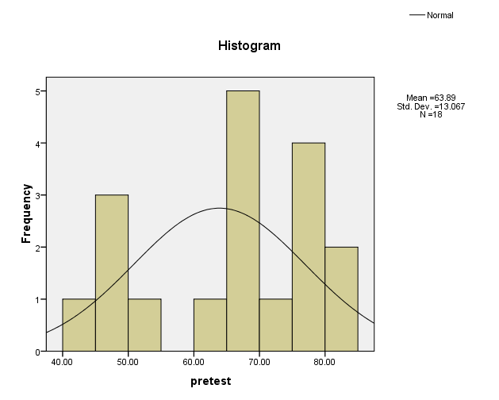

Chart 4: The score distribution based on the results of the posttest (Experiment Group)

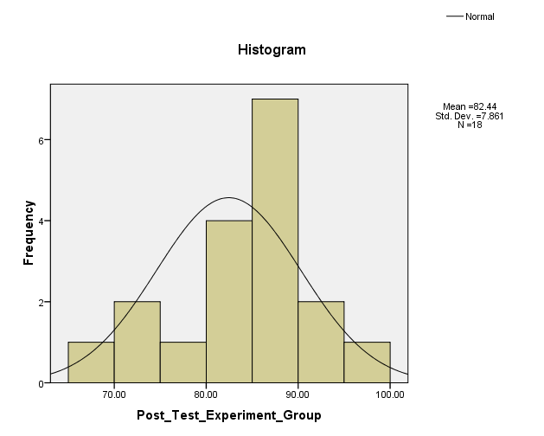

**4.1.2 Normality of pre-test and post-test in experiment group**

The normality test of pre-test and post-test in exepriment group was shown in the following table:

**TABLE 7**

| **One-Sample Kolmogorov-Smirnov Test** | | | |
| --- | --- | --- | --- |
|  |  | pre_testexperiment | post_testexperiment |
| N | | 18 | 18 |
| Normal Parametersa | Mean | 63.8889 | 79.8611 |
| Std. Deviation | 13.06720 | 12.46973 |
| Most Extreme Differences | Absolute | .201 | .271 |
| Positive | .134 | .153 |
| Negative | -.201 | -.271 |
| Kolmogorov-Smirnov Z | | .851 | 1.150 |
| Asymp. Sig. (2-tailed) | | .464 | .142 |
| a. Test distribution is Normal. | |  |  |
|  |  |  |  |

After doing the normal parameter test, the writer could conclude from the asymp. Significant level sig. (2 tailed), because the test of asymp. Sign (2 tailed) so the value is 0.05 and the criteria of the test were:

* If the value of significant or probability value > 0.05, so Ho is accepted
* If the value of significant or probability value < 0.05, so Ho is rejected

Based on the data in table one smaple kolmogrov-smirnov test, the value of asymp.sig.(2 tailed) in pre-test experiment was 0.464 and post-test experiment was 0.142. because all value of the variables higher than probbality value 0.05. so, the conclusion was all variables or value was distributed normally.

**4.1.3 the Homogenety of pre-test and post-test experiment group**

The calculation of homogeneity test in pre-test and post-test control group shown in the following table:

**TABLE 8**

| **Test of Homogeneity of Variances** | | | |
| --- | --- | --- | --- |
| Scores |  |  |  |
| Levene Statistic | df1 | df2 | Sig. |
| .007 | 1 | 34 | .935 |

In the table of homogeneity above, the resercher found the output used for knowing the variances of two score in sample. The hypothesis that used was:

Ha : variances sample is not homogeny

Ho : variances sample is homogeny

The criteria of the test:

* If the probability or sig.value > 0.05, so Ho is accepted
* If the probability or sig. value < 0.05, so Ho is accepted

Based on the value output of homogeneity oof variances found that the value of levene test was 0.007 with the probability value was 0.935. because of the probability value was > 0.05, so Ho was accepted or variances of the sample was homogeny.

**4.1.4 The Analysis of Post-test and Pre-test in Experiement Group by Using Paired Sample t-test**

**TABLE 9**

**The data Analysis of Experiment Group**

|  |  |  |  |  |
| --- | --- | --- | --- | --- |
| **Sample** | **Pre-test**  **( $X_{1}$)** | **Post-test**  **( $X_{2}$)** | **D** | $$D^{2}$$ |
| 1 | 40 | 65 | 25 | 625 |
| 2 | 45 | 70 | 25 | 625 |
| 3 | 45 | 70 | 25 | 625 |
| 4 | 47 | 75 | 28 | 784 |
| 5 | 50 | 82 | 32 | 1024 |
| 6 | 60 | 82 | 22 | 484 |
| 7 | 65 | 85 | 20 | 400 |
| 8 | 67 | 87 | 20 | 400 |
| 9 | 65 | 87 | 22 | 484 |
| 10 | 65 | 85 | 20 | 400 |
| 11 | 67 | 87 | 20 | 400 |
| 12 | 70 | 80 | 10 | 100 |
| 13 | 75 | 87 | 12 | 144 |
| 14 | 75 | 95 | 20 | 400 |
| 15 | 75 | 90 | 15 | 225 |
| 16 | 77 | 85 | 8 | 64 |
| 17 | 80 | 82 | 2 | 4 |
| 18 | 80 | 90 | 10 | 100 |
| **∑ n =18** | **∑ ${\overline{X}}_{1}$ = 1148** | **∑ ${\overline{X}}_{2}$ = 1484** | **∑D = 336** | ${∑D}^{2}$**= 7288** |
|  | ${\overline{X}}_{1}$**= 63.78** | ${\overline{X}}_{2}$**= 82.44** |  |  |

The SD of the data above is the following:

$$SD= \sqrt{\frac{\sum{D^{2 }}-\left(\frac{1}{n}\right) {\left(\sum{D}\right)}^{2}}{n-1}}$$

$$SD= \sqrt{\frac{7288-\left(\frac{1}{18}\right) {\left(336\right)}^{2}}{18-1}}$$

$$SD= \sqrt{\frac{7288-\left(0.05\right)\left(112896\right) }{17}}$$

$$SD= \sqrt{\frac{7288-5644.8 }{17}}$$

$$SD= \sqrt{\frac{1643.2}{17}}$$

$$SD= \sqrt{96.66}$$

$$SD=9.83$$

$$S\overline{d}= \frac{SD}{\sqrt{n}}$$

$$S\overline{d}= \frac{9.83}{\sqrt{18}}$$

$$S\overline{d}= \frac{9.83}{4.24}$$

$$S\overline{d}= 2.32$$

$$t_{obt}= \frac{{\overline{X}}_{1}– {\overline{X}}_{2}}{S\overline{d}}$$

$$t_{obt}= \frac{63.78-82.44}{2.32}$$

$$t_{obt}= \frac{18.66}{2.32}$$

$t_{obt}=$ 8.043

Based on the calculation above describe that the total score pre-test was 1148 and post-test was 1484. There was significant improvement avarege between pre-test score was 63.78 and post-test experiment was 82.44, t-obt was 8.043.

**4.1.5 The Score Distribution pre-test and post-test in Control Groups**

**TABLE 10**

**The Score Distribution pre-test and post-test in Control Groups**

|  |  |  |  |  |  |
| --- | --- | --- | --- | --- | --- |
| **Score Interval** | **Category** | **Pre-test** | | **Post-test** | |
| **Frequency** | **Percentage** | **Frequency** | **Percentage** |
| 86 -100 | Very Good | 0 | 0 % | 0 | 0 % |
| 76 – 85 | Good | 3 | 16.7 % | 11 | 61.1 % |
| 66 – 75 | Fair | 6 | 33.3 % | 7 | 38.9 % |
| 56– 65 | Poor | 4 | 22.2 % | 0 | 0 % |
| 00 – 55 | Very Poor | 5 | 27.8 % | 0 | 0 % |
| **Total** | | **18** | **100%** | **18** | **100%** |

Table 10 above described that pre-test in the control group, none student was in the very good category. three students (16.7%) were in the good category. six students (33.3%) were in the fair category. four students (22.2%) were in the poor category. and five students (27.8%) were in the very poor category.

Meanwhile, in post-test in the control group, eleven students (61.1%) were in the very good category. seven students (38.9%) were in the good category. none student was in the fair poor category. none student was in the poor category and none student was in the very poor category.

Chart 1: The score distribution based on the results of the pretest (Control Group)



Chart 2: The score distribution based on the results of the posttest (Control Group)

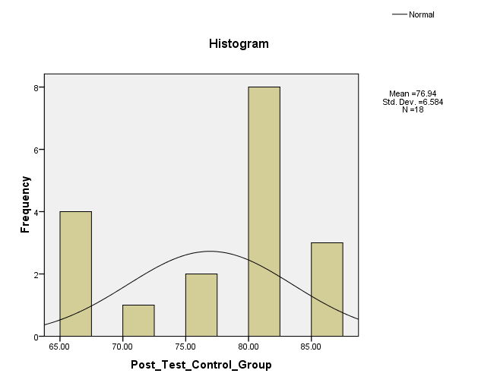

$\sqrt{\begin{aligned} \\ \\ \begin{aligned} \\ \\ \begin{aligned} \\ \begin{aligned} \\ \\ \\ \begin{aligned} \\ \\ \begin{aligned} \\ \\ \\ \begin{aligned} \\ \begin{aligned} \\ \\ \begin{aligned} \\ \\ \\ \\ \\ \begin{aligned} \\ \\ \begin{aligned} \\ \\ \\ \begin{aligned} \\ \\ \\ \\ \\ \begin{aligned} \\ \\ \\ \\ \\ \\ \frac{∑D2-\left(\frac{1}{n}\right)\left(∑D\right)2}{n-1}\end{aligned}\end{aligned}\end{aligned}\end{aligned}\end{aligned}\end{aligned}\end{aligned}\end{aligned}\end{aligned}\end{aligned}\end{aligned}\end{aligned}\end{aligned}}$**4.1.6 Normality of Pre-test and Post-test in the Control Group**

The normality of pre-test and post-test in the control group was shown in the following table **:**

**TABLE 11**

| **One-Sample Kolmogorov-Smirnov Test** | | | |
| --- | --- | --- | --- |
|  |  | pre_testcontrol | post_testcontrol |
| N | | 18 | 18 |
| Normal Parametersa | Mean | 63.8889 | 76.2500 |
| Std. Deviation | 13.06720 | 13.29114 |
| Most Extreme Differences | Absolute | .201 | .245 |
| Positive | .134 | .150 |
| Negative | -.201 | -.245 |
| Kolmogorov-Smirnov Z | | .851 | 1.039 |
| Asymp. Sig. (2-tailed) | | .464 | .231 |
| a. Test distribution is Normal. | |  |  |
|  |  |  |  |

From the table above, the test distribution of pre-test and post-test in control group is normal. Because asymp.sign 0.464 and 0.231 > 0.05, and the criteria of the test were :

* If the value of significant or probability value > 0.05, so Ho is accepted
* If the value of significant or probability value < 0.05, so Ho is rejected

Based on the data in table sample one sample kolmogrov-smirnov test. The value of Asymp.sign(2 tailed) in pre-test control was 0.464 and post-test control was 0.231. because all value of the variables higher than probability value 0.05. so, the conclusion was all variables or value was distributed normally.

**4.1.7 The Homogeneity of Pre-test and Post-test in the Control Group**

**Table 12**

| **Test of Homogeneity of Variances** | | | |
| --- | --- | --- | --- |
| Scores |  |  |  |
| Levene Statistic | df1 | df2 | Sig. |
| .040 | 1 | 34 | .843 |

In the table homogeneity above, the researcher found the output used for knowing the variances of two score in sample. The hypothesis that used was:

Ha : variances sample is not homogeny

Ho : variances sample is homogeny

The criteria of the test :

* If the probability or sig. Value > 0.05, so Ho is accepted
* If the probability or sig. Value < 0.05, so Ho is rejected

Based on the value output test of homogeneity of variances found that the value of levene test was 0.040 with the probability value was 0.843. because of the probabilty value was > 0.05, so Ho was accepted or variances of the sample was homogeneity.

**4.1.8 The Analysis of Post-test and Pre-test in the Control Group by Using Paired Sample t-test**

**TABLE 13**

**The Data Analysis of Control Group**

|  |  |  |  |  |
| --- | --- | --- | --- | --- |
| **Sample** | **Pre-test**  **( $X_{1 }$)** | **Post-test**  **( $X_{2}$)** | **D** | $$D^{2}$$ |
| 1 | 40 | 67 | 27 | 729 |
| 2 | 45 | 67 | 22 | 484 |
| 3 | 45 | 67 | 22 | 484 |
| 4 | 47 | 70 | 23 | 529 |
| 5 | 50 | 80 | 30 | 900 |
| 6 | 60 | 67 | 7 | 49 |
| 7 | 65 | 80 | 15 | 225 |
| 8 | 67 | 75 | 8 | 64 |
| 9 | 65 | 80 | 15 | 225 |
| 10 | 65 | 85 | 20 | 400 |
| 11 | 67 | 80 | 13 | 169 |
| 12 | 70 | 75 | 5 | 25 |
| 13 | 75 | 80 | 5 | 25 |
| 14 | 75 | 82 | 7 | 49 |
| 15 | 75 | 85 | 10 | 100 |
| 16 | 77 | 80 | 3 | 9 |
| 17 | 80 | 80 | 0 | 0 |
| 18 | 80 | 85 | 5 | 25 |
| **∑ n =18** | **∑ ${\overline{X}}_{1}$ = 1148** | **∑ ${\overline{X}}_{2}$ = 1385** | **∑D = 237** | ${∑D}^{2}$**= 4491** |
|  | ${\overline{X}}_{1}$**= 63.78** | ${\overline{X}}_{2}$**= 76.94** |  |  |

The SD of the data above is the following:

$$SD= \sqrt{\frac{\sum{D^{2 }}-\left(\frac{1}{n}\right) {\left(\sum{D}\right)}^{2}}{n-1}}$$

$$SD= \sqrt{\frac{4491-\left(\frac{1}{18}\right) {\left(237\right)}^{2}}{18-1}}$$

$$SD= \sqrt{\frac{4491-\left(0.05\right)\left(56169\right) }{17}}$$

$$SD= \sqrt{\frac{4491-2808.45 }{17}}$$

$$SD= \sqrt{\frac{1682.55}{17}}$$

$$SD= \sqrt{98.97}$$

$$SD= 9.95$$

$$S\overline{d}= \frac{SD}{\sqrt{n}}$$

$$S\overline{d}= \frac{9.95}{\sqrt{18}}$$

$$S\overline{d}= \frac{9.95}{4.24}$$

$$S\overline{d}= 2.35$$

$$t_{obt}= \frac{{\overline{X}}_{1}– {\overline{X}}_{2}}{S\overline{d}}$$

$$t_{obt}= \frac{63.78-79.94}{2.35}$$

$$t_{obt}= \frac{13.16}{2.35}$$

$t_{obt}=$ 5.60

Based on the calculation above describe that the total score pre-test was 1939 and post-test was 2196. There was significant improvement avarege between pre-test score was 63.78 and post-test experiment was 76.94, t-obt was 5.60.

**4.1.9 The Analysis of the data by Using Independent t-test**

In this part, the t-test formula was applied to find out whether there was any significant difference between the students’ average score in the experiment group and the post-test in the control group. Table 14 showed the total score and average score of the post-test of the experiment group and the post-test of the control group in the matched pairs, the total gained and the total score of square of the gained scores.

**TABLE 14**

**The Analysis Score of post-test in the Experiment and the Control Groups**

|  |  |  |  |  |  |  |
| --- | --- | --- | --- | --- | --- | --- |
| **Pairs Sample** | **Post-test**  **Experiment Group**  **(X)** | **Post-test**  **Control Group**  **(Y)** | **X** | **Y** | $$X^{2}$$ | $$Y^{2}$$ |
| 1 | 65 | 67 | -17 | -9 | 289 | 81 |
| 2 | 70 | 67 | -12 | -9 | 144 | 81 |
| 3 | 70 | 67 | -12 | -9 | 144 | 81 |
| 4 | 75 | 70 | -7 | -6 | 49 | 36 |
| 5 | 82 | 80 | 0 | 4 | 0 | 16 |
| 6 | 82 | 67 | 0 | -9 | 0 | 81 |
| 7 | 85 | 80 | 3 | 4 | 9 | 16 |
| 8 | 87 | 75 | 5 | -1 | 25 | 1 |
| 9 | 87 | 80 | 5 | 4 | 25 | 16 |
| 10 | 85 | 85 | 3 | 9 | 9 | 81 |
| 11 | 87 | 80 | 5 | 4 | 25 | 16 |
| 12 | 80 | 75 | -2 | -1 | 4 | 1 |
| 13 | 87 | 80 | 5 | 4 | 25 | 16 |
| 14 | 95 | 82 | 13 | 6 | 169 | 36 |
| 15 | 90 | 85 | 8 | 9 | 64 | 81 |
| 16 | 85 | 80 | 3 | 4 | 9 | 16 |
| 17 | 82 | 80 | 0 | 4 | 0 | 16 |
| 18 | 90 | 85 | 8 | 9 | 64 | 81 |
| **∑n = 18** | **∑X = 1484** | **∑Y = 1385** | **∑X = 8** | **∑Y= 17** | ${∑X}^{2}$**=1054** | ${∑Y}^{2}$**=753** |
|  | **∑X = 82** | **∑Y = 80** |  |  |  |  |

Mean variable X : $M_{1 }$ $\frac{\sum{X}}{N}$ = $\frac{1484}{18}$ = 82

Mean variable Y : $\frac{\sum{Y}}{N}$ = $\frac{1385}{18}$ = 76

SD variable X : $M_{1}$ = $\sqrt{\frac{\sum{X^{2}}}{N}}$ = $\sqrt{\frac{1054}{18}}$ = 7.65

SD variable Y : $M_{2}$ = $\sqrt{\frac{\sum{Y^{2}}}{N}}$ = $\sqrt{\frac{753}{18}}$ = 6.47

Standard error M1 and standard error M2

= = = = = 1.86

= = = = = 1.57

Standard error difference between M1 and M2

= = + = = = 2.43

So, = = = 2.469

$t_{0}$ was 2.469 while t-table (at p>0.05 at df=(18+18) – 2=34= 2.042). Because t-obt (2.469) was higher than t-table (2.042). It meant that Ho is rejected and Ha is accepted.

**4.2 Interpretation of the Findings**

Based on the finding above, in the post-test, the mean score of the experiment group was 1484. The highest score that the sudents reached in the experiment group was 95, while the lowest was 65. The mean score of the control group was 1385. The highest score that the sudents reached in the control group was 85, while the lowest was 67. It can be seen that there was an increase from the average score of the test results achieved by students at the post-test, but the mean score of the experiment group was higher than the control group. It can be assumed that the student who were taught vocabulary using LINCS strategy was better than the students who were taught without using LINCS strategy. There was a real significance difference between experimental group and control group. So, the students in the experiment group could answer questions about the material with easily and got better score.

It showed that LINCS strategy used by the writer was improve vocabulary. The finding is supported by the following comments from the researchers. Haines, Shelby Brooke, (2003) states that the effectiveness of the LINCS strategy was determined after approximately 6 – 7 weeks of instruction; Ellis, Edwin S. (1998:14) states that the LINCS strategy can be used to help students remember importat new terms and significance names, places, events or processes to significantly increase test.

The writer would like to say that “LINCS strategy” could make the students active and interested in learning vocabulary. During the experiment, the writer observed that most of the students were involved in the classroom actively. Finally, “LINCS strategy” can be used as as one of the means in teaching vocabulary at elementary school.

Based on the finding above, there were some of result study could be interpreted. First, in the post-test, the mean score of the experiment group was 1484. The highest score that the sudents reached in the experiment group was 95, while the lowest was 65. The mean score of the control group was 1385. The highest score that the sudents reached in the control group was 85, while the lowest was 67. It can be seen that there was an increase from the average score of the test results achieved by students at the post-test, but the mean score of the experiment group was higher than the control group. This was because of the experiment group had received teaching vocabulary using LINCS strategy, while the control group received teaching vocabulary without using LINCS strategy. So, the students in the experiment group could answer questions about the material with easily and got better score.

Finally, LINCS strategy could improve Vocabulary to the fourth grade students of SD Negeri 12 Indralaya. Pair find that it could improve teaching vocabulary the finding from Haines, Shelby Brooke, (2003) said that the effectiveness of the LINCS strategy was determined after approximately 6 – 7 weeks of instruction; Ellis, Edwin S. (1998:14) states that the LINCS strategy can be used to help students remember importat new terms and significance names, places, events or processes to significantly increase test.