Students’ Perceptions on the Use of Google Classroom in Writing Activities
A Case Study at SMAN 1 Banyuasin 3
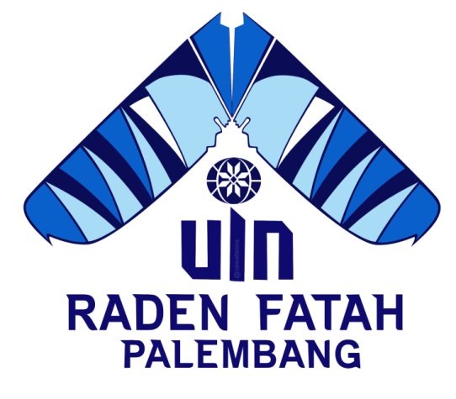
UNDERGRADUATE THESIS

Submitted as fulfillment of requirements to get a bachelor’s degree of
Sarjana Pendidikan (S. Pd)

By
Ririn Marina
NIM: 1652500109
Advisors:
- Hj. Lenny Marzulina, M.Pd
- Deta Desvitasari, M.Pd

ENGLISH EDUCATION STUDY PROGRAM
FACULTY OF TARBIYAH AND TEACHING SCIENCES
UNIVERSITAS ISLAM NEGERI RADEN FATAH PALEMBANG
2022

DEDICATION
This thesis is dedicated to:
- My wonder God (Allah SWT), I am so much grateful for all the blessing that you have given to me that can make me strong and keep on my track.
- My big family especially my beloved parents, father (Alm. Marozi), mother (Nurjanah), stepfather (Ramdon) and my beloved siblings (Robby Pramana and Reni Angelina) thanks a lot for your love, time, pray, care, support, motivation, and other amazing unrequited sacrifices to me so that I can finish this thesis.
- My amazing advisors, Hj. Lenny Marzulina, M. Pd and Deta Desvitasari, M. Pd, thank you so much for your time to guide me in advisory until I can finish this thesis.
- All of my inspiring lecturers that I cannot mention it one by one. Thank you so much for your time and participation in the process of finishing this thesis.
- Thank you to my special friend Andre S.Psi who has really supported me during the process of completing this thesis.
- Thanks to all of my Classmates specially Nova, Tika, Pepi, Nabila, Rifda, Nadia, Rere thank you so much for the time that we spent together during the process of finishing this thesis.
- Thank you for all of my beloved friends that i cannot mention it one by one.
- Thanks to my beloved department, almamater and campus.

MOTTO
“Respect your self, Respect your process without thinking that other people are better than you”
(Ririn Marina)

STATEMENT PAGE
I hereby,
Name : Ririn Marina
Place and Date of Birth : Pangkalan Balai, June 16th 1997
Study Program : English Education Study Program
Student Number : 1652500109
State that,
- All the information, interpretations, and conclusions presented in this thesis, except for those indicated by the sources are the result of my observation, process thought with the guidance of my advisors.
- The thesis that I wrote is original and has never handed in for another academic degree, neither at UIN Raden Fatah Palembang nor other universities. This statement is made truthfully and if one day, there is evidence of forgery in the above statement, I am writing to accept the academic sanction of cancellation of my degree that I have received through this thesis.
Palembang, June 2022
The Writer

Ririn Marina
NIM.1652500109

