IMPROVING STUDENTS’ READING COMPREHENSION BY USING K-W-L (KNOW, WANT TO KNOW, LEARNED) STRATEGY TO THE TWELFTH GRADE STUDENTS OF SMA MANDIRI PALEMBANG

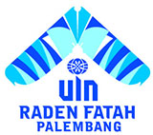

UNDERGRADUATE THESIS

Submitted as a fulfillment of requirements to get
a bachelor’s degree of Sarjana Pendidikan (S.Pd)

By:
Khofifah Indah Sari
NIM. 1820205063

ENGLISH EDUCATION STUDY PROGRAM
FACULTY TARBIYAH AND TEACHING SCIENCES
STATE ISLAMIC UNIVERSITY (UIN) RADEN FATAH PALEMBANG
2023

