Lampiran 1.
SK Pembimbing
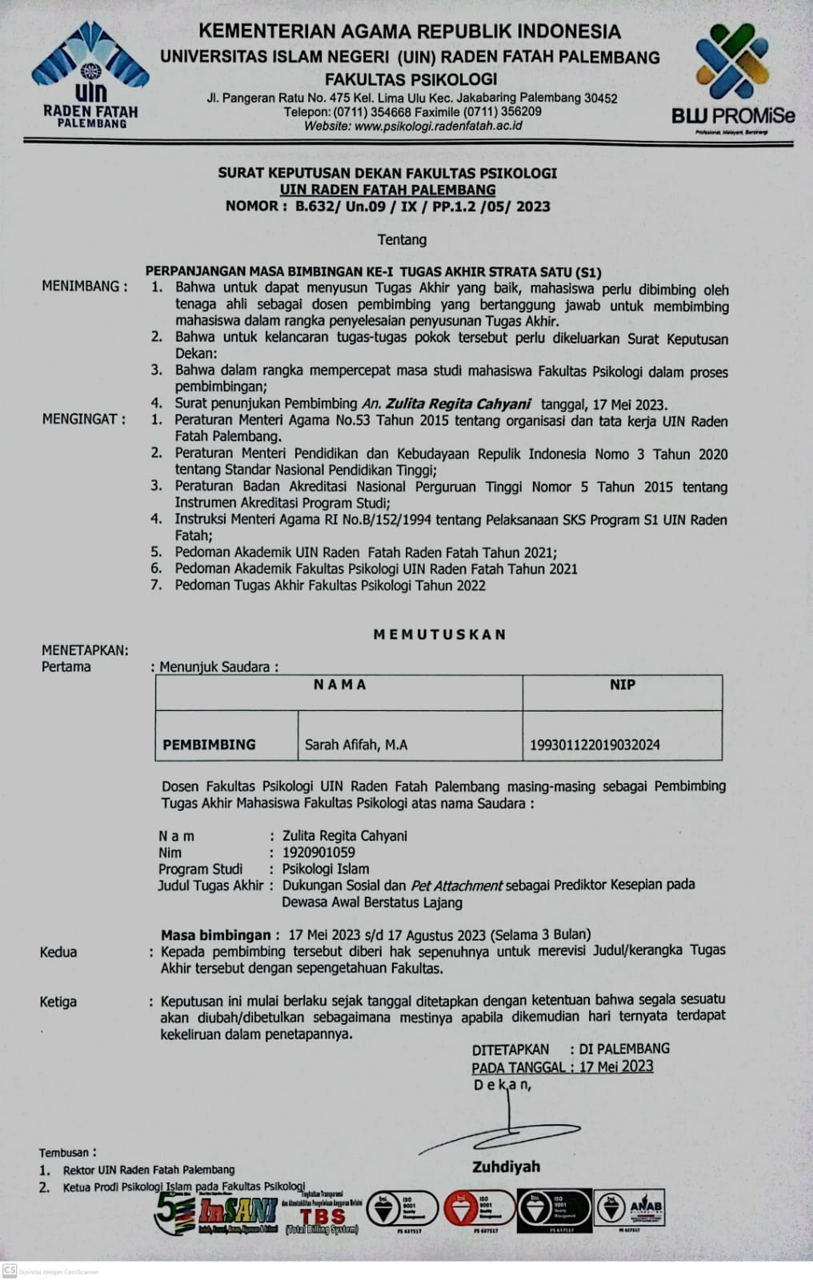
Lampiran 2.
Surat Izin Penelitian
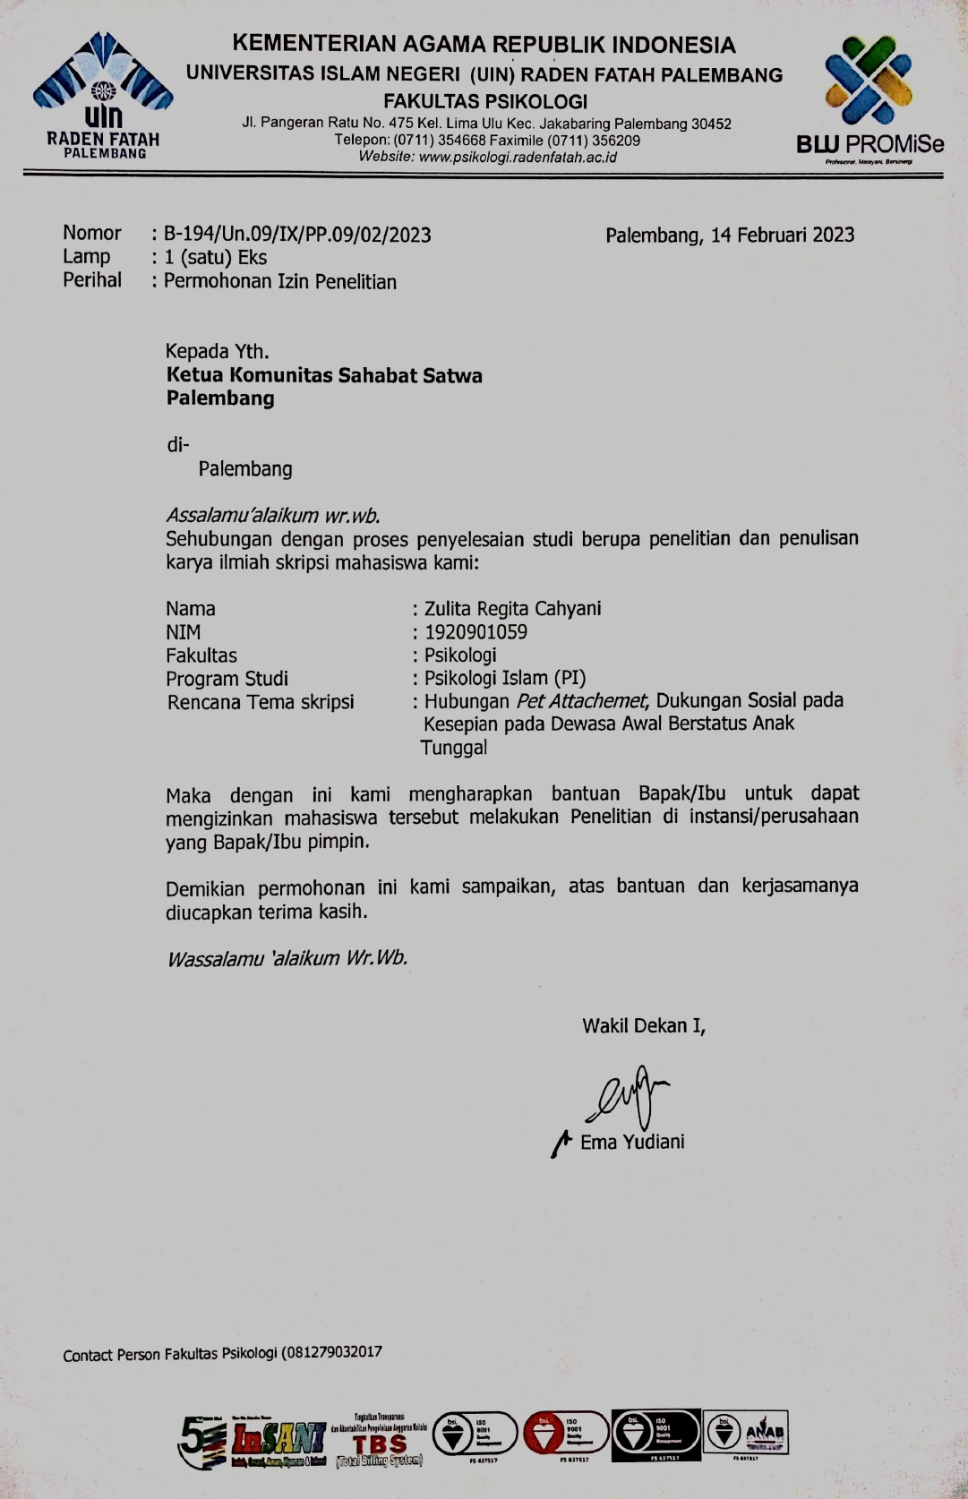

Lampiran 3.
Surat Balasan Izin Penelitian
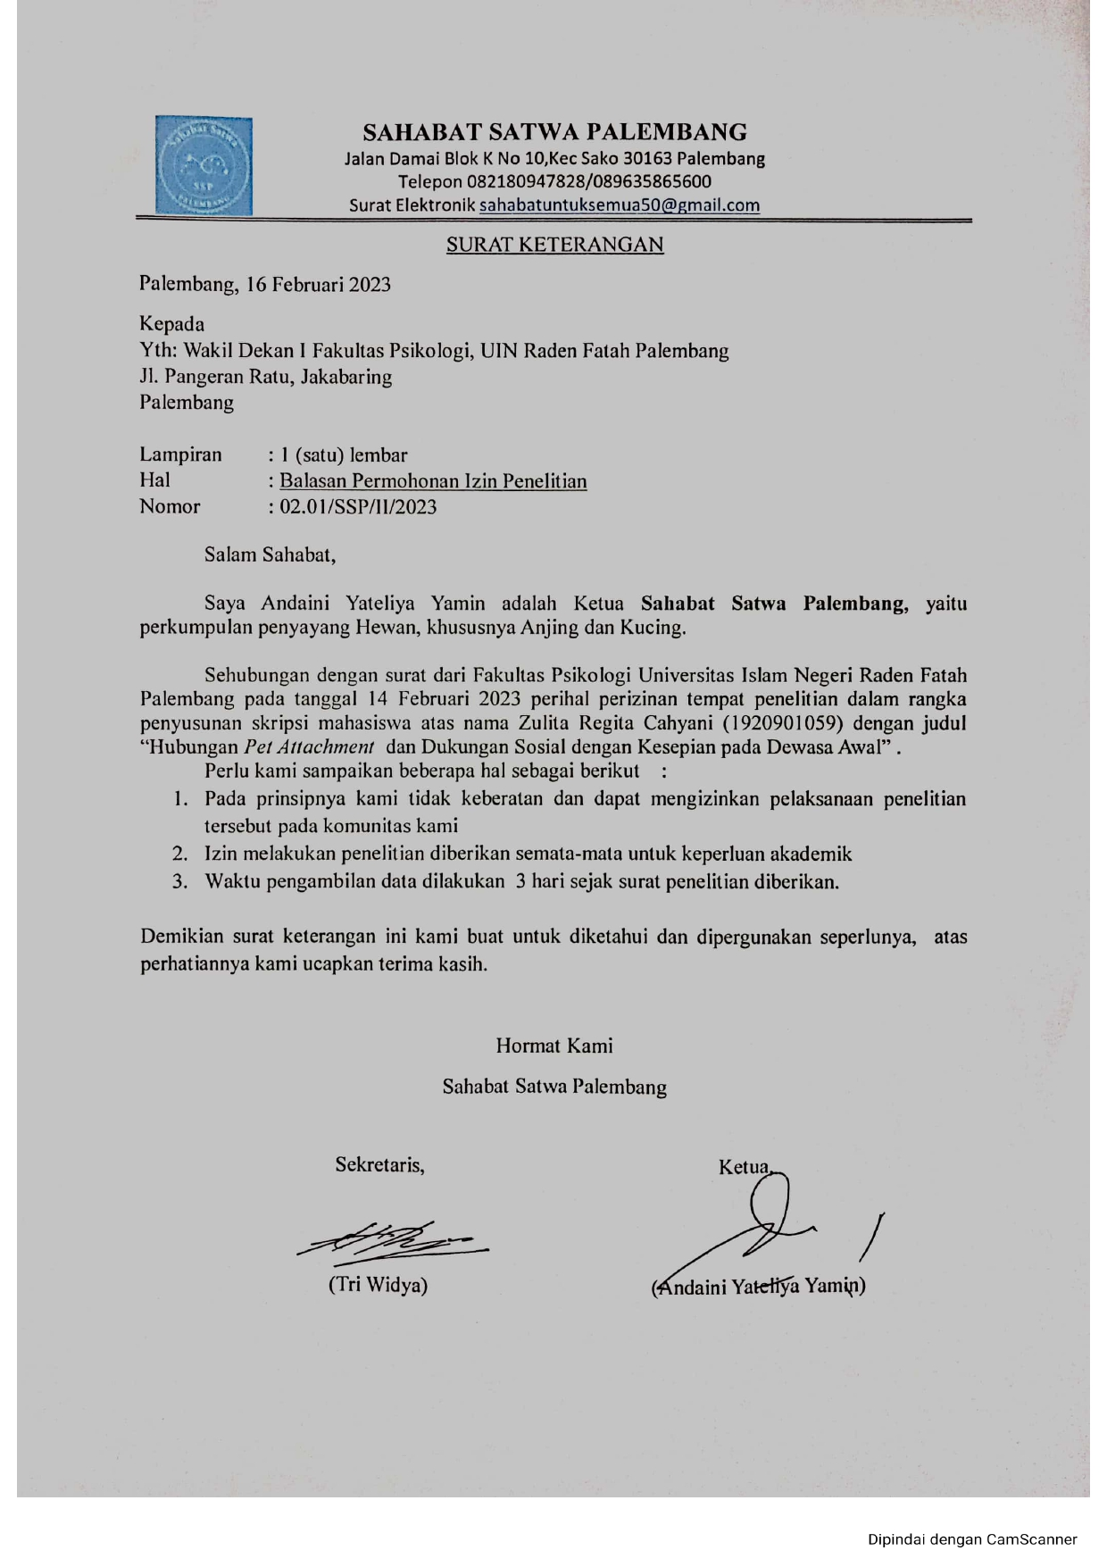

Lampiran 4.
Lembar Konsultasi Pembimbing
