STUDENTS’ DIFFICULTIES IN WRITING RECOUNT TEXT AT SMA BINA WARGA 2 PALEMBANG



UNDERGRADUATE THESIS
Submitted as a fulfillment of requirements to get the tittle of Sarjana Pendidikan (S.Pd)

MUHAMMAD RAFLI
2020205022

ADVISORS

- Ridha Ilma, M.Pd
- Deta Desvitasari, M.Pd

ENGLISH EDUCATION STUDY PROGRAM
FACULTY OF TARBIYAH AND TEACHING SCIENCE

STATE ISLAMIC UNIVERSITY OF RADEN FATAH PALEMBANG

2023
DEDICATION AND MOTTO

This thesis is dedicated to:
- My wonderful God, Allah SWT. Thank you for all the blessings and mercies that has been given, so I can finish this thesis and also Prophet Muhammad SAW, as my greatest role model.
- My beloved mother, Mrs. Roslaini who always hard work, being my advisor and supporting me in any condition. Thank you for giving me true love, pray, care, support, and everything for my life. I also would like to give my special thanks to my father, Mr. Helpi Syahril, S.Sos. Thank you to my beloved sisters and brother Ade Ria Marcelli, Am.Keb , Dina Meilina Am.Keb and Degarintova Darma Putra
- Thank you to my inspiring advisors Mrs. Ridha Ilma, M.Pd and Miss. Deta Desvitasari, M.Pd who guided me and give me the great advices, kindness and patience during the process of writing my thesis.
- My special thanks are presented to the tenth grade students of SMA Bina Warga 2 Palembang. Thanks a lot for your kindness and willingness to be the participants of my thesis.
- My senior high school and university best friends I ever have: Rio Putra Pratama a.k.a Rio wakaf, Aryani Rahmawati Sukarno Putri, Delak Septiani, Dewi Parantika Sari, Rizki Dania, Rizka Annisa, Irena Nur Annisa, Siti Chairunnisa, Acry Larasandi, M. Fajri, M. Ihsan Syuhada, Afif Setiawan, Haris firnando, Zullia Tri Lestari, Riski Koko, Azizah Lyanti, S.H. , M. Nico Juniansyah, Ansarullah, Venny Aprillia, Chastuti Alwalliyah, Chairun Niswah, Siti Choiriah, Try Jeni Adelia, Salsa Afifah, Viera Inesya, Amelia Rahmadini, Lydia, Abi Farhan, Endri, Dian, Fenty, Tika, dipi,
Aldi, Sayid , Efran, Naufal and Raiz. Thank you for always by my side, assisting me and give me unconditional love.
- I would like to say thank you very much to My older brother Mr. Febro Savier Ferdinand, and also Rizka, Zaza, Sophia for giving me support, motivation, and help me through the writing this thesis.
- I also want to thank to my best buddies: Ardilla Aprilia, Ayu Muzzuhria, Heppy Savira, M. Rizki Adha, M. Naufal, M. Bilhakki Thank you for being my mood-booster all this hard time.
- I want to thank myself for getting through this, for believing in myself, and for never giving up through this hard time.
- Last, i want to thank to my HMPS teams : Nabila, Thoriq, Enggar, Imam, Oyi, Nesya , Indah, Alifah, Anisa Trisna, Annisa Humairoh, Azmi, Desti, Parsa, Febri, Yerico and all of 2021 class. Thank you for giving me happiness in every situation at the campus.

MOTTO

Ketahuilah bahwa kemenangan bersama kesabaran, kelapangan bersama kesempitan, dan kesulitan bersama kemudahan -HR Tirmidzi
مَنْ صَبَرَ ظَفِرَ
Man Shabara Zhafira
( barang siapa yang bersabar, ia akan beruntung)

STATEMENT PAGE
The Researcher here by:
Name : Muhammad Rafli
Students Number : 2020205022
Place and Date of Birth : Palembang, August 11th 2003
Study Program : English Education
State that:

- All the data, information and interpretation and conclusion presented in this thesis, except for this indicated by the source are the result of my though, writing test and interview with the guidance of my advisors.
- This undergraduate thesis the researcher wrote is originally and has never been handed in for another academic degree at UIN Raden Fatah Palembang or other universities.
This statement is made truthfully, and if one day there is evidence of forgery in the statement above. The researcher is willing to accept the academic sanction of the cancellation of degree that the researcher received through this undergraduate thesis.

Palembang, 30 April 2024
The researcher,

Muhammad Rafli
NIM. 2020205002

ACKNOWLEDGMENT
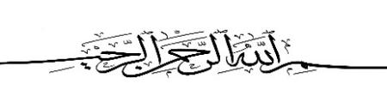
Alhamdulillahi rabbil ‘aalamiin. First of all, millions of thanks are given to Allah SWT, the one and only God and the lord of the world and the hereafter, for giving me a good health and chance to complete this thesis entitled “Students’ Difficulties In Writing Recount Text at SMA Bina Warga 2 Palembang”. Invocation and peace go to prophet Muhammad SAW, the Holy Prophet, his family, and his disciples. May Allah bless and give them peace.
The researcher would like to express the greatest gratitude to my beloved family and friends for their love, prayers, and support which they give to me. Hopefully, Allah give them the best of all. Secondly, my deepest goes to my advisors, Mrs. Ridha Ilma, M.Pd and Miss. Deta Desvitasari, M.Pd who are willing to spend their time to guide me to improve my thesis. The researcher is grateful for their advices, suggestions, and support in the process of writing my thesis. The researcher also very grateful to the Head and Secretary of English Education Study Program, the Dean of Tarbiyah and Teaching Science Faculty, as well as all of his staff members for the administration. The researcher would like to thanks for third semester English education students at UIN Raden Fatah Palembang who give me access to interview and to be part of my research.
Then, people who have given me hand, that the researcher could not mention one by one. My wholehearted thanks to them will never be enough but researcher believed that God blesses them all.
Palembang , 30 April 2024
The researcher,

Muhammad Rafli
NIM.2020205022
TABLE OF CONTENT

ACKNOWWLEDGEMENT i
TABLE OF CONTENT ii
LIST OF TABLES iv
LIST OF APENDICES vi
LIST OF DOCUMENTATION ix
ABSTRACT 1
CHAPTER I INTRODUCTION
1.1 Background of the study 1
1.2. Problem of The Study 6
1.3. Objective of The Study 6

1.4. Significances of The Study 6
a. English teacher 6
b. Students 6
c. Other researchers 6
d. The researcher himself 6
CHAPTER II LITERATURE REVIEW
2.1. Writing
2.1.1 Process of Writing 8
2.1.2 Components of Writing 9
1) Content 9
2) Formalized organization 9
3) Grammatical 9
4) Vocabulary 9
5) Physics 10
2.1.3 The Purpose of Writing 10
2.2 . Concepts of Writing Recount Text 11
2.2.1 Generic Structure of Recount Text 12
2.2.3 Language Feature of Recount Text 13
2.3. Difficulties in Writing 13
1. Handwriting 13
2. Spelling 13
3. Layout and Punctuation 13
2.3.2 Difficulties in Writing Recount Text 14
2.4 . Previous Related Studies 15
CHAPTER III METHOD OF RESEARCH
3.1 Research Design 19
3.2 Operational Definitions 19
a. Students’ Difficulties 20
b. Recount Text 20
3.3 Participants of the Study 20
3.4 Data Collection 21
3.4.1Interview 21
3.4.2Documentation...........................................................................................................21
3.5. Data Analysis 22
3.6. Establishment of trustworthiness 23

CHAPTER IV FINDING AND DISCUSION
4.1 Reseacrh Findings 24
4.1.1 Students Difficulties in writing recount text 24
4.1.1.1 Lack of vocabularu in writing 27
4.1.1.2 Lack of generating generic structure of recount text 28
4.1.1.3 Incoretct grammar use 30
4.2 Discusion 31
CHAPTER V CONCLUSION AND SUGGESTION
5.1. Conclusions 33
5.2. Suggestions 34
REFERENCES 35
INTERVIEW GUIDELINE 38
TRANSCRIPT OF INTERVIEW RESULT 15
TRANSCRIPT OF INTERVIEW RESULT 19
TRANSCRIPT OF INTERVIEW RESULT 23
TRANSCRIPT OF INTERVIEW RESULT 27
TRANSCRIPT OF INTERVIEW RESULT 31
DOCUMENTATION 36

LIST OF TABLES
Table 4. 1. 1 Theme and codes of the Students’ difficulties in wring recount text.

LIST OF APPENDICES

Appendix A : Interview Indicator
Appendix B : Interview Protocol
Appendix C : Validation Sheet of Research Instrument
Appendix D : Interview Transcription Result
Appendix E : Transcription Approval Sheet
Appendix F : Documentation

ABSTRACT

Writing is one of the most important skills that should be mastered by the students. From writing students can explore their mind and give information to the readers. This study aimed to find the difficulties faced by tenth grade students in SMA Bina Warga 2 Palembang in writing recount text. This research was used qualitative research approach, specifically a case study design, used to explore the difficulties faced by tenth grade students in writing recount text. This study was used homogeneous sampling to select the participants from the tenth grade class, six students were selected as participants who have difficulties in writing recount texts. Data collection involved interviews and documentation. Thematic analysis was used to analyzing the data. The result of the study showed that students encountered difficulties when writing recount text such as lack of vocabulary in writing, lack of generating generic structure of recount text and incorrect grammatical uses. The result of this study helped the teacher to find out their student’s difficulties in writing recount text and then this research give contribution for English teacher to pay attention more when teaching writing especially recount text. Additionally, this research made the students aware of their difficulties in writing recount text appropriately and this research will motivate the students to make their writing better.
Keywords : recount text, students difficulties, writing.

CHAPTER I
INTRODUCTION
This chapter discusses (1) background of the study, (2) problems of the study, (3) objectives of the study, (4) and significances of the study

  - Background of the study

Language cannot be separated from human life because language is one of important tools. According to Algeo (2010), a language is a system of conventional vocal sign by means of which human beings communicate. Language and people have a relationship because the development and growth of language walk together with the development of people’s lives. People use language to communicate to each other in daily life. Amberg & Vause (2009) state that language is a foremost means of communication which is communication almost always takes place within social life. Language also used to express ideas, opinion, thoughts and feelings. In summary, language is an indispensable aspect of human existence, serving as a vital tool for communication and expression.
English is one of language which is used by many people to communicate to each other. Algeo (2010) define that English has become the most widespread language in the world. In Indonesia, English is taken as a foreign language. One of the examples is an international language which has an important role in education area. According to Harmer (2007), English as a foreign language tends to be learn so that people can use English when travelling or communicating with other people who speaks English. In indonesia, English is taught as a foreign language in school from elementary up to university.

In conclusion, English is a widely used language globally, with Indonesia considering it a foreign language. It plays a crucial role in education, with English taught from elementary to university levels, enabling communication and travel with English-speaking individuals.
In learning English, it always relates to the four skills. According to Choudhury (2013) the four core of language skills are listening, speaking, reading and writing. However in this research, the researcher only focuses on productive skills especially in writing. Hossain (2015) state that writing skills is a productive skills and useful tool for learning process. In learning English, writing skills is very important to students because it is the most used skill in evaluating students’ performance in almost all levels of education. In conclusion, this research focuses on productive writing skills, as they are crucial for students' performance evaluation at all levels of education, as they are a key component of the four core language skills.
Writing is one of the most important skills that have to be mastered by the students. From writing students can explore their mind and give information to the readers. According to Brown (2001), state that writing is a thinking process. The phrase "writing is a thinking process" refers to the idea that writing is not merely a means of conveying thoughts and ideas; rather, it is a cognitive process that helps individuals develop and refine their thinking. When people engage in the act of writing, people are forced to organize our thoughts, analyze information, and make connections between different concepts. According to Harmer (2004), writing along with speaking, listening and reading, is one of the most important skills in language learning. Writing is one of the

language skills to share ideas what students think (Hinkel, 2004) . And then, writing also plays an important role in the students learning process. Writing is very important, because communication is not only oral language, but even written language. Therefore, students should improve their writing and practice a lot to make meaningful writing. Rasulullah SAW also told us to write in a hadits : "When you hear something (of knowledge) then write it down even on a wall." (Reported by Abu Khaitsamah in Al-Ilmu no.146). The students should comprehend the structure and materials in writing, because it is the key to make good writing. In brief, writing is an important skill for students because it allows them to develop their brains while also conveying information to readers. As a result, students should practice and enhance their writing skills in order to produce meaningful and effective communication. Furthermore,
Students must learn and understand some of English texts in the first grade of Senior High School. According to Hermawan (2022) in English subject, 10th grade high school students will study four texts: descriptive text, recount text, narrative text, and exposition text. As a result, recount text is one of the elements that must be taught to students in school, and it is critical that students learn and grasp the components of recount text thoroughly. In conclusion, students must comprehend English text in the first grade of senior high school, including narrative, exposition, recount and descriptive texts. In the classroom, students need to fully understand the components of recount texts, which are an essential learning tool.
Recount text is a text type which is similar to narrative text. Darla & Zitnay (2012) state that recount is one of non fiction text types because it is tell about a specific person or event. It is a factual and chronological account of events that occurred in a specific order or sequence. In a recount text, the writer provides a detailed description of what happened, often using a first-person or third-person narrative style. According to Wardiman (2008), there are generic structures such as orientation, events, and re-orientation. First, orientation is background information needed to understand the text, such as who was involved, where it happened, and when it happened. Second events are a series of events, ordered in a chronological sequence. Then, re-orientation is a personal comment about the event or what happened in the end. Recount is a non-fiction story detailing a specific person or event in a specific order or sequence. It uses generic structures like orientation, events, and re-orientation to provide background information, chronological succession of events, and personal opinions on the event's outcome.
Based on the syllabus for Senior High School at SMA Bina Warga 2 Palembang, there are some types of text that should be learned by the students such as descriptive text, recount text, narrative text and so on. In this research, the researcher decides to choose recount text among the texts because it helps students are able to retelling their experience. According to Gerot and Wignel (1994), recount is retelling past events in order to entertain or to inform what have already happened. It means that recount text is the text that retells past events in order in which they happened.
Based on the preliminary study during the third internship that the researcher conducted at SMA Bina Warga 2 Palembang on the year 2023, he had checked the results of students' writing about recount text that has been done by students. It was found that the students’ scores were below the learning objective achievement criteria or KKTP ( Kriteria Ketercapaian Tujuan Pembelajaran ) . Half of the number of students in the class get a score below 50. After that, the researcher confirmed the data with the English teacher who taught the class, and it was confirmed that students had difficulty in writing recount text. Then, the researcher interviewed the teacher, it was confirmed that she was not satisfied with the results of the recount texts done by the tenth grade students. In conclusion based on data, the researcher confirmed that the students still had problems in writing recount text and the The English teacher said that there are still difficulties when students write recount texts.
There was several previous studies related to this study, the first is study by Purnomo (2023), he showed that Students faced seven difficulties in writing narrative texts: expressing ideas, grammar and spelling, structure or organization, vocabulary and spelling, and in grammar and vocabulary. Secondly, a study by Ariani (2023), she found that this research aimed to analyze students’ difficulties in writing recount text at the 8th grade students Based on the result of the research, the most difficult aspects of writing recount encountered by the students were in term of grammar, and then followed by the use of verb, capitalization, the use of to be, punctuation, spelling, preposition, and vocabulary. The last was study by Harris (2014) From the results of this study, it found that the difficulties faced by students when writing recount texts are by students when writing recount texts, namely in the use of language features. This difficulty relates to the use of simple past tense, action verb, linking verb, and pronoun.
Therefore, based on the explanation by the previous studies above, the researcher was interested to focus the research on analyzing student writing difficulties, entitled “ Students’ Difficulties in Writing Recount Text at SMA Bina Warga 2 Palembang”.

Problem of The Study

The problem of this study was what were the students’ difficulties in writing recount text at SMA Bina Warga 2 Palembang?

Objective of The Study

The objective of this study was to find out the students’ difficulties in writing recount text at SMA Bina Warga 2 Palembang.

Significances of The Study

By conducting this research, it is expected that the results of this study will be useful information and positive contributions for:
    - English teacher
The result of this study will help the teacher to find out their student’s difficulties in writing recount text and then this research give contribution for English teacher to pay attention more when teaching writing especially recount text.
    - Students

This study is to inform and to make the students aware of their difficulties in writing recount text appropriately and this research will motivate the students to make their writing better.
    - Other researchers

This research can be used as a reference for conducting a future research.
    - The researcher himself
The researcher wants to know what are the difficulties that are faced by the students and to add researchers insight in deep, especially into students’ difficulties in writing recount texts.

CHAPTER II

LITERATURE REVIEW
This chapter discusses : (1) Writing (2) Concept of writing recount text (3) Difficulties in writing (4) Previous related studies
2.1 Writing

Writing is one of the most important abilities that students must learn. Writing allows pupils to explore their brains while simultaneously presenting readers with knowledge. Writing, according to Brown (2001) is a "thinking process." It means that writing is a written product produced by a writer based on their thinking after going through the thinking process. Nunan agrees, stating that "writing is the process of thinking to invent ideas, thinking about how to express ideas into statements and paragraphs clearly.It means that students are expected to explore their ideas and arrange them into good sentences and paragraphs that have meaning. Writing is thus not only the activity of producing language in written form, but also a means of communicating ideas. According to Amanda et al (2023) stated that writing is a complex activity because writers are required to be able to compile and organize the content of the goal. When writers begin writing, they not only record all of their ideas, but they also filter them. The writers must convey and organize their ideas into a meaningful text with some meanings. Thus, writers should be able to explore ideas and understand how to make ideas easily understandable.
Writing can be defined as a written productive language competence. Harmer (2001) stated that the goal of writing ability is to transfer information from spoken language to written language. It is a fundamental skill that allows individuals to express their thoughts, ideas, and emotions in a structured and coherent manner. Through writing, people can communicate with a wide audience, leaving a lasting record of their thoughts and experiences. This skill is not only essential for effective communication but also plays a crucial role in various aspects of life, including education, professional endeavors, and personal expression. As a result, when producing a recount text, writers should retell their thoughts in textual form that has some meaning.

2.1.1 Process of Writing

The process of writing involves a series of thoughtful and deliberate steps. Harmer (2004) divides the writing process into four parts. The following stages of the writing process are explained:
      - The first stage of the writing process is planning, where writers prepare, try, and decide what they will write.
      - Drafting is a stage of the writing process in which writers organize their ideas before putting them into final form.
      - Editing (reflecting and revising) is a procedure in which authors create a draft and then revise what they wrote to determine where the errors in writing occurred.
      - Final Draft is the last stage of the writing process when the written text is ready to send to its intended audience. In brief, writing process is a sequence of tasks that assists the writer in making plans with writer thoughts, expressing them on paper, revising the document, and sending it to its intended audience.
From the explanation above, It can be inferred that there are some writing processes that writers should adhere to. It assists the writer in producing good writing from start to completion.

2.1.2 Components of Writing

Understanding the essential components of writing is crucial for developing effective communication skills. According to Harris (1996) , writing has five general components, they are :

- Content

The author's ideas are described. Although easy writing, content refers to sentences that flow readily and are not too difficult for readers to understand.
- Formalized organization

The content is organized systematically in order for it to be cohesive. It contains reasonable sentences that support the writing's topic. The writers' ideas are properly arranged and easily comprehended by the reader.
- Grammatical

The syntactic and grammatical patterns. Grammar is concerned with how words should be ordered to form good sentences. In the tense good indicates right and meaningful. It denotes that the writers used the proper grammatical qualities to convey her message or information to the readers.
- Vocabulary

Vocabulary is important in the construction of a strong paragraph. The writer was able to smoothly invent their ideas by using acceptable terms. They can convey concepts to readers by making proper choices.

- Physics

The application of linguistic conventions.It means that readers can benefit from clear information by utilizing acceptable grammar, spelling, capitalization, and so on.The writer should grasp how to write and the mechanics of writing. It is possible to conclude that there are components in writing. It is essential for the writer to remember in order to develop good writing.
In conclusion, writing as five components: content, organized in a formalized manner, and grammatical errors. Content describes the author's ideas, while organized systematically for coherence. Grammatical errors involve the arrangement of words to produce sentences, with good grammar indicating appropriate and meaningful communication.

2.1.3 The Purpose of Writing

Writing serves several purposes for the learner, including communication, critical thinking and problem solving, and self-actualization. According to Grenville (2001), there are three purposes of writing, such as :
- Writing is used to communicate.

Writers use writing to express their feelings, arguments, and thoughts.Writer explains everything in writing to gain readers' comments. Writing is the
primary media through which students exhibit their grasp and interpretation of concepts and theories studied.
- Writing is used to stimulate critical thinking and problem solving.

Writing allows the writer to explore his or her deepest thoughts and feelings. Writing can help a writer find gaps in comprehension and thought patterns. Writing is a method of defining difficulties and clarifying the writer's knowledge .

- Writing serves as a means of self-actualization.

Writing is a method of discovering and developing a writer's ideas; it is also a means of self-actualization for the writer. Writing is a contemplative, ever- evolving ability that allows writers to explore many aspects of themselves as unique individuals.It can be inferred that writing is a communication instrument used by the writer. The writer can explore their ideas and solve their difficulties by writing.
To sum up, writing can help students with communication, critical thinking, problem solving, and self-actualization. It enables writers to communicate their sentiments, ideas, and views, solicit reader feedback, and demonstrate their comprehension of concepts. Writing also promotes critical thinking by helping writers to examine their deepest thoughts, find gaps in understanding, and clarify their knowledge. Writing is also a form of self- actualization, allowing writers to find and develop their distinct personalities.

2.2 Concepts of Writing Recount Text

Students must be able to compose a variety of text in academic writing, including recount text. A recount text is one that recounts prior occurrences. According to Anderson & Anderson (1998) a recount text is a piece of text that retells past events, typically in the sequence in which they occurred. Its goal is to provide the listener with a description of what happened and when it happened. This indicates that recount text describes a previous occurrence to the listener. The goal of a literary story recount is to tell a series of events in order to entertain and instruct the audience.Hyland, on the other hand, claimed that recount text is used to recreate prior experiences by recalling events in their original sequences.

The text in writing retells about the true context that occurred in the past based on original sequences, thus it must be ordered systematically of events that occurred.

2.2.1 Generic Structure of Recount Text

In learning recount text, the students should know the generic structure of recount text, according to Wardiman (2008) state that they are three generic structure of recount text :
1. Orientation

The reader of a recount text is told who was involved, what happened, where the event occurred, and when it occurred. For example : last year, they went to to an Islamic school in Palembang.
2. Events

Tell what happened and in chronologically or the middle of story what sequence. For example : after they went to that school, they said that they remember their own moments there. After that, they try to went to the school canteen.
3. Re-orientation

The story's ending. In other words, this is a type of prose that describes how something happened in the past chronologically as well as the feelings associated with that event. Some recounts include an evaluative note orconclusion that may represent the writer's take on the previously stated incident, but this is entirely optional. For example : After they were satisfied with their tour of the school, they went home.
To sum up, Students should understand the generic structure of recount text, which includes orientation, events, and re-orientation. Orientation tells the readerabout the event, its location, and time. Events describe the events chronologically, with a middle sequence. Re-orientation describes the story's ending, including feelings and feelings associated with the event. Some recounts may include an evaluative note or conclusion.

2.2.3 Language Feature of Recount Text

There are language features of recount text based on Sudarwati and Grace (2014). They are as follows :
- Introducing personal participant : I, my group, my family, my school, etc.

- Using chronological connection : the, first, next, after that, first of all, etc.

- Using linking verb ; was, were, saw, heard, etc.

- Using action verb: looked, went, changed, ran, arrived, took, laughed, etc.
- Using Simple Past tense

2.3 Difficulties in Writing

2.3.1 Kinds of Difficulties In Writing

Writing abilities are really valuable in life. It is not only vital in academic life, but also in people's lives, yet it is tough for students. According to Harmer (2003) there are three difficulties in writing :
- Handwriting
The students difficult to understand handwriting because each person has different style to write, it is become a problem in writing by the students
- Spelling
The students are weak to identifying component sounds in the words that they try to spell. The students are poor in linking sounds and syllables to correct groups of letter
- Layout and Punctuation
Layout is the way when the parts of something are arranged. It is convention when writing is designed to make comprehension easier for reader. Punctuation is the way to use comma, full stop and others in a sentence.
In conclusion, writing abilities are highly valuable in various aspects of life, but many students face challenges in this area. Writing presents three challenges: developing handwriting skills through practice, deciphering students' unique writing styles, and addressing spelling challenges. Handwriting is a skill that can be improved with practice, while spelling is a challenge for children. Layout and punctuation are essential for enhancing clarity and readability. Layout involves organizing text, headings, and images, while punctuation marks are used to enhance reader comprehension. Despite these challenges, with determination and consistent effort, one can improve their writing abilities.

2.3.2 Difficulties in Writing Recount Text

The difficulties in writing recount text are in generic structures consist of orientation not events and orientation. According to Supatmi (2013) , there are several difficulties faced by students in writing recount text ;
- Generic Structure

The first difficulties faced by the students in writing in the part of generic structure, which involves effectively distinguishing between orientation and events within the narrative.
- Language Features

The second difficulties that faced by the students in writing recount text is in the grammar mastery or language features of the recount text consist of personal participant, simple past tense, linking verb and action verb. Addressing these challenges systematically and providing targeted support can significantly enhance students' proficiency in crafting well-structured and linguistically accurate recount texts, ultimately fostering their overall writing competence.
In the process of writing recount text, the students faced some problems. Alisha (2019) stated that the most significant problems are lack of vocabulary and they are difficult to develop their ideas and to put their ideas in an appropriate sentences. It is make students feel difficult when they write recount text. Finally,Students faced difficulties in writing recount text due to generic structures and language features. They struggle to distinguish between orientation and events and develop ideas in appropriate sentences. In addition, Mustafa (2021) stated that the students still made errors in writing recount text. the researcher concludes that the students did not understand or could not use past tense verbs correctly in their sentences. Addressing these challenges can enhance students' proficiency in crafting well-structured and linguistically accurate recount texts. The most significant problems are lack of vocabulary and difficulty in developing ideas.

2.4 Previous Related Studies

There were several previous studies related to this study, the first is study by Purnomo (2023) entitled "An Analysis of Students’ Writing Narrative Text in class X SMA Al- Azhar Syifa Budi Solo. The study utilized a qualitative research method with a case study design to examine tenth-grade students' difficulties in learning writing skills, particularly narrative texts, at SMA Al- Azhar Syifa Budi Solo the subject in this study were students of class X Regular consist of 20 students. The result of this study was students faced seven difficulties in writing narrative text, they were expressing ideas, grammar and spelling, structure , vocabulary and spelling and in grammar and vocabulary.The difference between this research and the research was carried out by researchers lies in the research location where this research is located in the city of solo while the research that was conducted by researchers is located in the city of Palembang, the second difference lies in data analysis where this research uses data reduction, data display and conclusion drawing while the research conducted by researchers uses thematic analysis.The first similarities in these two studies lies in the topic in which both studies discuss student difficulties in writing skills, the second similarities lies in the research method in which these two studies both use qualitative methods, the last similarities lies in the participants in which these two studies both examine class X students at the high school level.
Another previous study by Ariani (2023) entitled "An Analysis of Students' Difficulties in Writing Recount Text. A qualitative analysis of eighth- grade students at SMP N 15 Kota Serang indicated writing issues, particularly in grammar, verb usage, capitalization, punctuation, spelling, preposition, and vocabulary.The first differences lies in the population used by previous research and research that was conducted where previous research took participants of 8th grade students at the junior high school level while the research that was carried out took participants from 10th grade high school students. The second differences lies in the location of the research, where the previous research was carried out in the city of Serang, while the research that was carried out by researchers in the city of Palembang.The similarity between these two studies lies in the research topic, namely that they both research students' difficulties in writing recount texts, and the similarities between the two studies lie in the research method, where both studies use qualitative research methods.
The third is an article entitled Students’ Difficulties in Writing Recount Text at The Eighth Grade of SMP Murni 1 Surakarta in 2014/2015 Academic Year by Ratnasari (2014) . The study examines eighth-grade students' ability to write recount texts at SMP Murni 1 Surakarta, identifying difficulties such as arranging generic structures, changing tense, correct grammatical sentence arrangement, choosing appropriate vocabulary, and delivering their ideas. It also explores the teacher's solutions to these issues, highlighting the need for improved teaching methods. The first differences lies in the participants, where the previous research used 8th grade junior high school students as participants, while the research that conducted by the researcher took participants from 10th grade high school students. The second differences lies in the research location, where the previous research was in the city of Surakarta and the research that was carried out by the researcher is in the city of Palembang. The last difference lies in the data collection, where the previous research used tests and the research that was carried out using interview and documentation.The similarity between these two studies lies in the research topic, in which the previous research and the research that was carried out by the researchers both examine students' difficulties in writing recount texts.
The fourth is study by Alfiyah (2021) entitled “An Analysis of Students’ Errors in Writing Recount Text, This study examines errors made by eighth grade A students at SMPN 19 Konawe Selatan in writing recount texts. Results show 47% linguistic category errors, 32% surface strategy errors, 20% communicative errors, and 1% comparative errors, particularly in writing English in recount texts.The first differences between the previous research and the research that was carried out lies in the participants, where the previous research took participants from grade 8 junior high school students, while the research that was conducted took participants from grade 10 high school level, the second differences lies in the research method where the previous research used quantitative methods and The research that was carried out by the researcher used qualitative research methods, the last differences lies in the data collection where the data obtained by the previous research was through a writing test and in the research that was carried out by the researcher collected the data through interview and documentation, the similarities between these two studies lie on the research topic where both studies examined students' difficulties in writing recount text.
The last is study by Yulianawati (2018) entitled “An analysis of Students’ Difficulties in Writing Recount text”. this study investigates causes of students’ difficulties, kinds of difficulties and the most dominant problem in writing recount text written by ten students at a Senior High School in Indramayu, West Java. The findings revealed that most students have been able to implement the generic structures and linguistic features of recount text, which indicates the ability of students to write the texts and to achieve its purpose. However, some students found difficulties in terms of the use of tenses, the use of vocabulary, and the use of specific participants.The first differences lies in the location of the research where the previous research was conducted in Indramayu while the research that was conducted by researcher is in Palembang city, the second differences lies in the number of participants where the previous research took 10 high school students and the research that was conducted by researcher amounted to 6 high school students.The similarities between these two studies are that both of these studies examine students' difficulties in writing recount texts and also both of these studies used a qualitative research approach.

CHAPTER III

METHOD OF RESEARCH
This chapter discusses : (1) research design (2) operational definitions (3) participants of the study (4) data collection (5) data analysis (6) Trustworthiness
  - Research Design

This study was used a qualitative method with a case study design. Because in this study the researcher only focused on one case intensively and in detail. The case referred to in this study is the difficulties experienced by students in writing recount texts. According to Yin (2020), Case studies are empirical investigations that investigate contemporary phenomena in real-life contexts.
In this research, the researcher tried to get a lot of data using qualitative research. According to Creswell (2012), qualitative research is the greatest technique to overcome a research problem that involves factors that you don't know about and need to investigate. This method focuses on words rather than numbers, which was also a qualitative feature of the method. That is, the qualitative method utilized in this study was writing to characterize an issue after gathering information. In brief, this study employed a qualitative method with a case study design, focusing on students' difficulties in writing recount text. Case studies are empirical investigations of contemporary phenomena in real-life contexts, utilizing qualitative research techniques to overcome unknown factors and characterize issues after gathering information.

Operational Definitions

To avoid misunderstanding, the researcher provided operational definition, as follow:

Students’ Difficulties

The students’ difficulties was the problems that students faced in expanding idea, grammar, and lack of vocabulary in writing recount text. In this study, students refers to Tenth Grade Students at SMA Bina Warga 2 Palembang, the difficulties in writing recount text.

b. Recount Text

Recount text is created to retell a story in order to enlighten or entertain its audience or readers (or both). Students are asked to convey their thoughts on the experience or recent occurrences in order to enlighten the readers.

3.3 Participants of the Study

In this research, the researcher used purposeful sampling with the type Homogeneous sampling method. According to Thomas (2022), purposeful sampling is the best option when a researcher use case study design because purposeful sampling improves the study continuity and accuracy of data and conclusion. Additionally, Thomas (2022) defined that homogeneous sampling is a type of purposeful sampling that aims to produce a homogeneous solution or one in which all the components have the same traits or properties. This method was chosen to gather information from participants with similar characteristics and a solid understanding of the study’s subject matter, making the research process more efficient and effective.
The location of this study was at SMA Bina Warga 2 Palembang and the researcher chose class X.2 and X.8 as participant in this study because there were students at that class had difficulties in writing recount text based on the preliminary study and based on teacher information. According to Kuzel (1992), he recommended 6 to 8 interviews for a homogeneous sample. Thus, in this research, the researcher took 6 students who have the lowest score of recount text . In this research, the researcher took 3 students from X.2 and the 3 students from X.8.
In conclusion, the approach of purposeful sampling with homogeneus sampling, which guarantees data accuracy and continuity, was used in this research. SMA Bina Warga 2 Palembang was the host of the study, which concentrated on classes X.2 and X.8, as they are the students who struggle with recount text writing. To guarantee a thorough and effective research procedure, the researcher chose six students with the lowest recount text score, including three students who were from X.2 and three students who were from X.8.

3.4 Data Collection

The interview and documentation was used for the research. According to Creswell (2009), there are four basic categories of data collection procedures in qualitative research. The goal of this study was to identified obstacles in creating recount text. This study detailed how to obtain data through interviews and documentation. Which are discussed in detail in the following sections:

3.4.1 Interview
An interview was required to obtain information from the informant. According to Creswell (2012), an interview occurs when the researcher poses open-ended questions to the participants in general and records their responses. In this study, the researcher used a semi-structured interview to interview the students one by one and ask them questions. Harmer (2004) used open-ended questions to address question indicators problems in writing The researcher undertook some procedures during the interview process, the first of which was the preparation of interview questions. The interview protocol was employed as an instrument in this

research when interviewing students. The researcher took notes on key points of the interview. Following that, the data is interpreted and conveyed narratively.
3.4.2 Documentation
Documentation is official paper that gives information based on evidence. Sarwono (2006) state that documentation is a tool to help researcher to collect the data and information by reading the letters, announcements, meeting summary, the written statements and the other writing. It means that, the researcher collected the data and got information by reading something. The researcher collected students’ assignment in writing recount text to answer the questions about what the students difficulties in writing recount text at the tenth grade students of SMA Bina Warga 2 Palembang.

3.5 Data Analysis

The researcher used thematic analysis to analyze the data. According to Creswell (2012), thematic data analysis includes distilling the way things operate and recognizing the fundamental aspects in themes in the cultural setting. According to Cresswell (2012), there are six steps to data analysis, which are as follows: First, data analysis was prepared, then the data was read, and then the data analyzed in detail using a coding process, and then coding the data applied for the process of describing the theme for analysis, the descriptions or themes described in the qualitative data in search of analysis, and finally the researcher interpreted the data.

3.6 Establishment of trustworthiness

Trustworthiness is the ultimate step in establishing qualitative research. Cresswell (2012) said that qualitative research is a process of collecting and analyze data, it need to be able to finding and interpretation are accurate. The researcher used triangulation of the data to enhance the validity and accuracy of the data. Sugiyono (2009) define that triangulation is the process of corroborating evidence from different individuals, type of data or methods of data collection in qualitative research. it means that, qualitative research is use to collect data analysis to make sure a finding and interpret accurate data.
There are several kinds of triangulation. According to setiyadi (2006), triangulation divided into 5 kinds, there are triangulation of time, triangulation of place, triangulation of theory, triangulation of method and the last is triangulation of researcher. In this research, member checking was conducted by sharing the interview transcript with the participant, particularly the students who were interviewed for their perspectives on the difficulties in writing recount text. Participants were given the opportunity to review the findings and provide feedback or corrections if there were any discrepancies or misunderstanding. Their input helped ensure that the interpretations of the data accurately reflected their experiences and perspectives. In this research, triangulation was achieved through the use of two primary methods : interviews and documentation review. Interviews provided insights directly from the students regarding their difficulties in writing recount texts, allowing for an in-depth exploration of their experiences and perspectives. Documentation review involved analyzing written materials such as students' past writing samples, teachers' feedback, and curriculum documents related to recount text writing. By comparing and contrasting data from interviews and documentation, the researcher was able to gain a comprehensive understanding of the students' difficulties in writing recount texts, enhancing the validity and trustworthiness of the findings. As a result, Through member checking and triangulation of methods, this qualitative research on students' difficulties in writing recount texts at SMA Bina Warga 2 Palembang ensured the trustworthiness and validity of the findings. By involving participants in the validation process and utilizing multiple data sources, the research aimed to provide a thorough and accurate depiction of the challenges faced by students in recount text writing.

CHAPTER IV
FINDINGS AND DISCUSSION
This chapter presents (1) Research Findings and (2) discussion

4.1 Research Findings
The aimed of this study were to find out the students’ difficulties in writing recount text. The researcher did the interview and got the data from documentation. As the result, the students faced some difficulties in vocabulary, understanding in generating generic structure of recount text and the grammatical mastery of recount text. The difficulties faced by the students when they asked to write recount text are listed in table 1 below :
Table 1
Students’ Difficulties in Writing Recount Text
NO The Difficulties in Writing Recount Text
1 Lack of Vocabulary Mastery  and Getting Idea | - Limitation of vocabulary  - Organizing idea  - Weak ability in arranging words

2 Lack of Understanding in  Generic Structure of  Recount Text  3 Lack of Grammatical Mastery | - Ignorance of the generic structure (orientation, events, re-orientation)  - Inability in composing paragraphs  - Simple Past Tense  - Personal pronoun  - Linking verbs  - Past Form of Verbs

4. 1. 1. Lack of Vocabulary Mastery
From the interview, the researcher found that the students had difficulty in producing some words. The problem was lack of vocabulary mastery. It is corroborated by the following interview:
“I think my English vocabulary is not enough to write a recount text. Particularly when I am told to write about my recent vacation, there is a possibility of encountering more complex vocabulary that I might not be familiar with.” (SR, Personal communication, February, 19th 2024)

It is inline with NM statement :
“I don’t believe my English vocabulary is strong enough for writing task. Sometimes I struggle to find the correct words to express myself.” (NM, Personal communication, February, 19th 2024)

Another statement by AA :
“I don’t think so sir, because I don’t remember” (AA, Personal communication, February, 19th 2024)

When the researcher looked at the students assignments, it was found that they could only write as much as two lines, it was indicated that the students had difficult in vocabulary mastery.
Figure 1
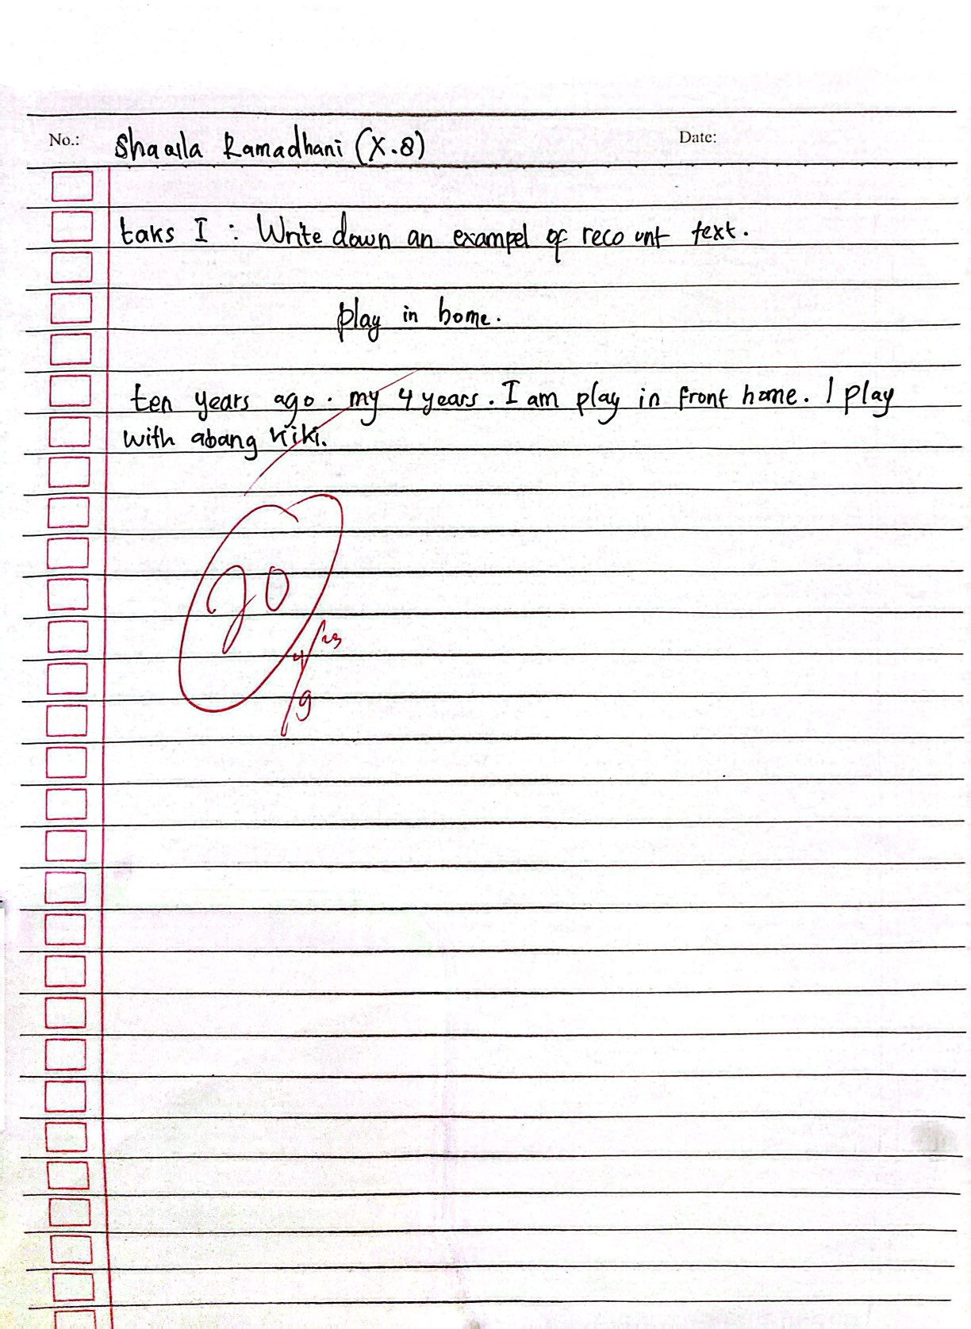

Source : Students’ Writing Assignment (SR)
From the interview and documentation above, the researcher could consider that the students can not develop their ideas because they had difficulty in producing words. This was because the students didn't know it, and they had a limited vocabulary and struggled to write sentences. This problem is caused students not being able to form good sentences due to their lack of vocabulary mastery.
4.1.2 Lack of Understanding in Generating Generic Structure of Recount Text
In accordance with the data collected through the interview and the documentation, the researcher found that the students’ had difficulty in generating the generic structure of recount text. The students had difficulty in writing the orientation, events and re-orientation . It is supported by interview below:
“I am aware that the orientation serves as the beginning of the text, but I am unsure about the specific content that should be included within that section.” (SR, Personal communication, February, 19th 2024)

Another statement is inline with NM :
“I don’t know very well about orientation but as I recall orientation is the opening paragraph” (NM, Personal communication, February, 19th 2024)

And then statement by NA :
“I am unfamiliar with the specific concept of “orientation” within the context of recount text. My understanding is that recount texts are primarily structured using paraghraph.” (NA, Personal communication, February, 19th 2024)

From the interview result, actually the students understand , but they had problems in elaborating the words into paragraph. The researcher can conclude the statements indicate the students had difficulty in developing idea when they write the text because they confused what they want to write. Then, events is a part of recount text that tell what happened and, chronologically, or in the middle of the story, what the sequence was.
Students AA stated that :
“ yes I find it very difficult to write a series of event in a recount text because I don’t know what words to write in that section” (AA,Personal Communication, February, 19th 2024)

It is inline with ME statement :
“Yes sir. Because of my limited vocabulary, I always struggle to organize events, especially in recount text”(ME,Personal Communication, February, 19th 2024)

Students MT also had similar problem :
“yes I find writing the events section very challenging. I struggle to organize my sentences and express the events clearly due to limited English vocabulary” (MT, Personal Communication, February, 19th 2024)

The last part of recount text is the re-orientation. Actually the students have learn about the structures of the recount text. But they still have any problems in writing re-orientation. It is supported by the interview below :
Students SR claimed that :
“in my personal opinion, the most challenging apects lies in combining personal reflections and conclusion within the re- orientation section, as instructed by the teacher.” (SR, Personal Communication, February, 19th 2024)

Another statement by MT :
“Yes I find writing the re-orientation difficult because they seem to have different meanings. I often get them confused and use them interchangeably” (MT, Personal Communication, February, 19th 2024)

When the researcher looked at the students assignments, he found that the students could not arrange a good paragraph using the right structure of the recount text. It was indicated that they had difficulties writing recount text using the generic structure of the recount text. The right structure of the recount text is orientation, events, and re-orientation.
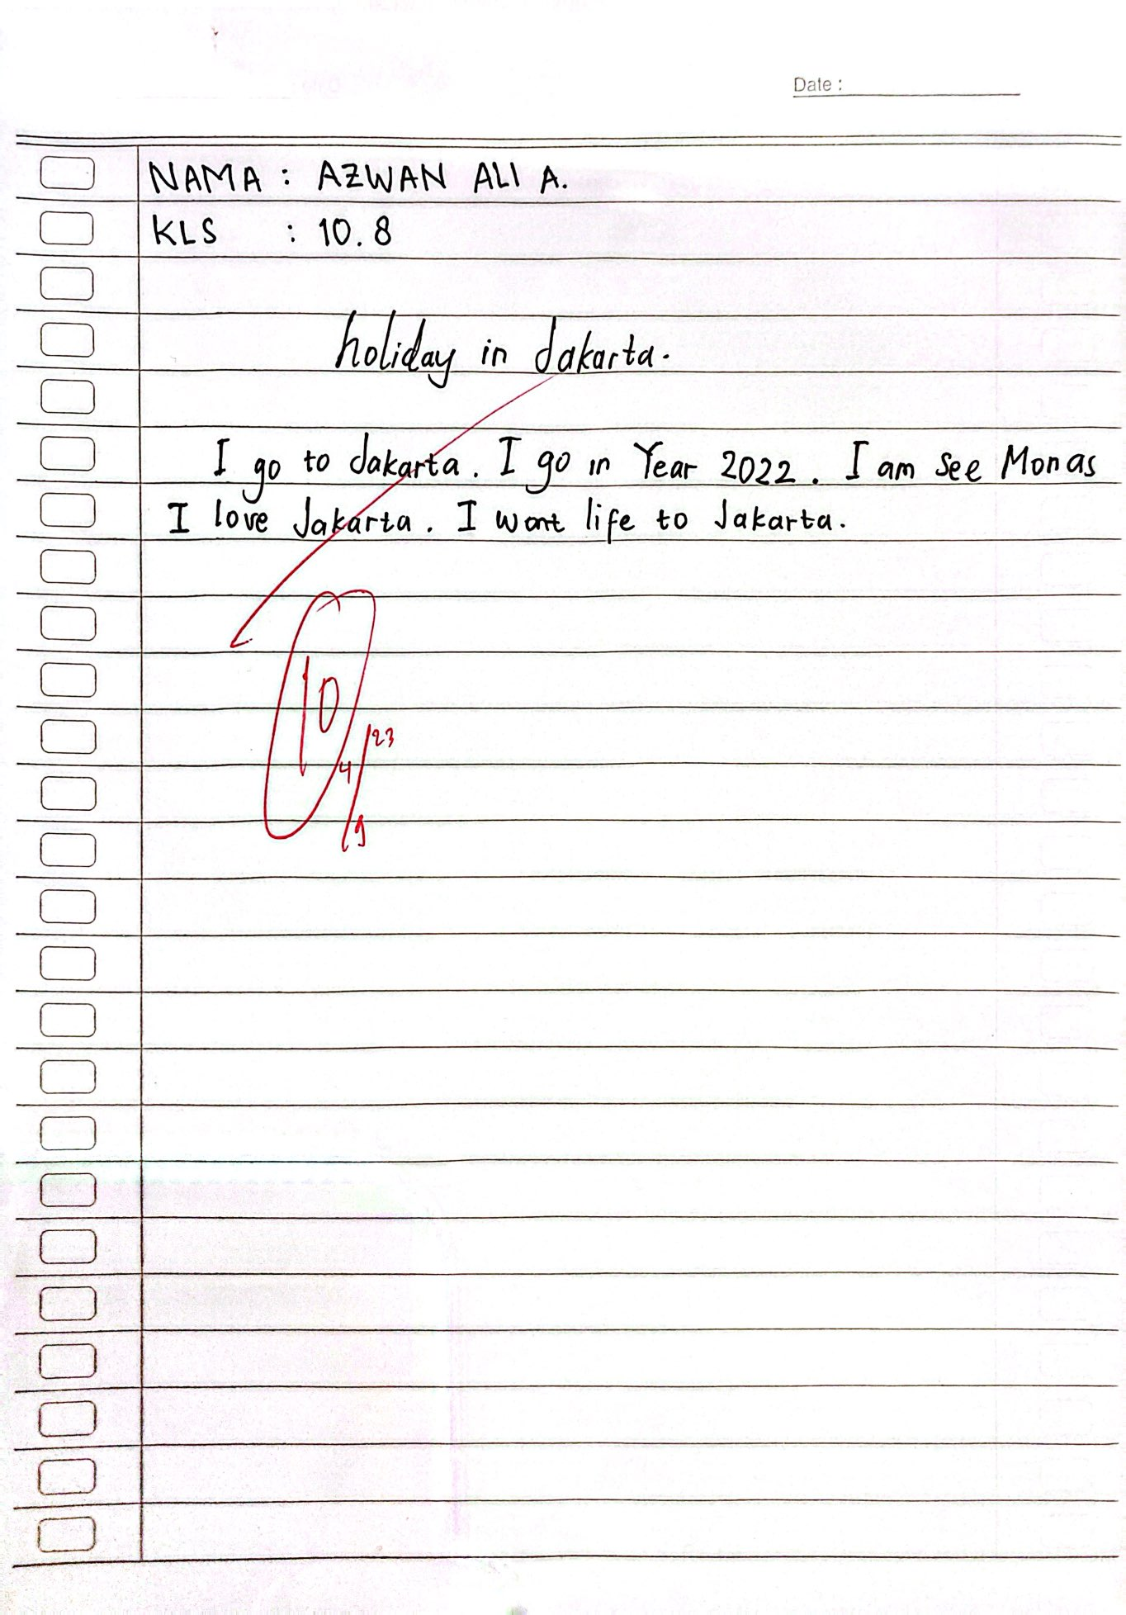
Figure 2

Source : Students’ Writing Assignment (AA)
From the interview and documentation, the researcher found the students have difficulties in writing orientation , events and re-orientation. The students have difficulties in writing recount text especially in the part of orientation because they don’t understand what orientation part is. This problem is caused by students are not being able to make good sentences due to their lack of vocabulary. And then the students have difficulties in writing recount part on the events and re-orientation section because they don’t understand what to write and what events is.

4. 1. 3. Lack of Grammatical Mastery
Simple past tense identifies an even that happen, or activity, action and/or state that has been done in the past time. And then after the interview and see the students assignment from the teacher , the researcher found that the students had difficulty in grammatical mastery , the use simple past tense in this case.
“actually, I have studied with friends but I still don’t understand. I don’t believe im proficient in using it in my writing.” (NM, Personal Communication, February, 19th 2024)

It is inline with SR statement :
“im less capable of using simple past tense because I can’t make a good recount text so its possible I won’t be able to use simple past tense” (SR, Personal Communication, February, 19th 2024)

Another Statement by ME :
“I think simple past tense is complicated. There is a formula” (ME, Personal Communication, February, 19th 2024)

As we can see from the students assignment below, it was found that the students did not change all the verb, in a recount text the correct verbs is the past form of the verbs and in the figure below, the students used the infinitive verbs.
Figure 3
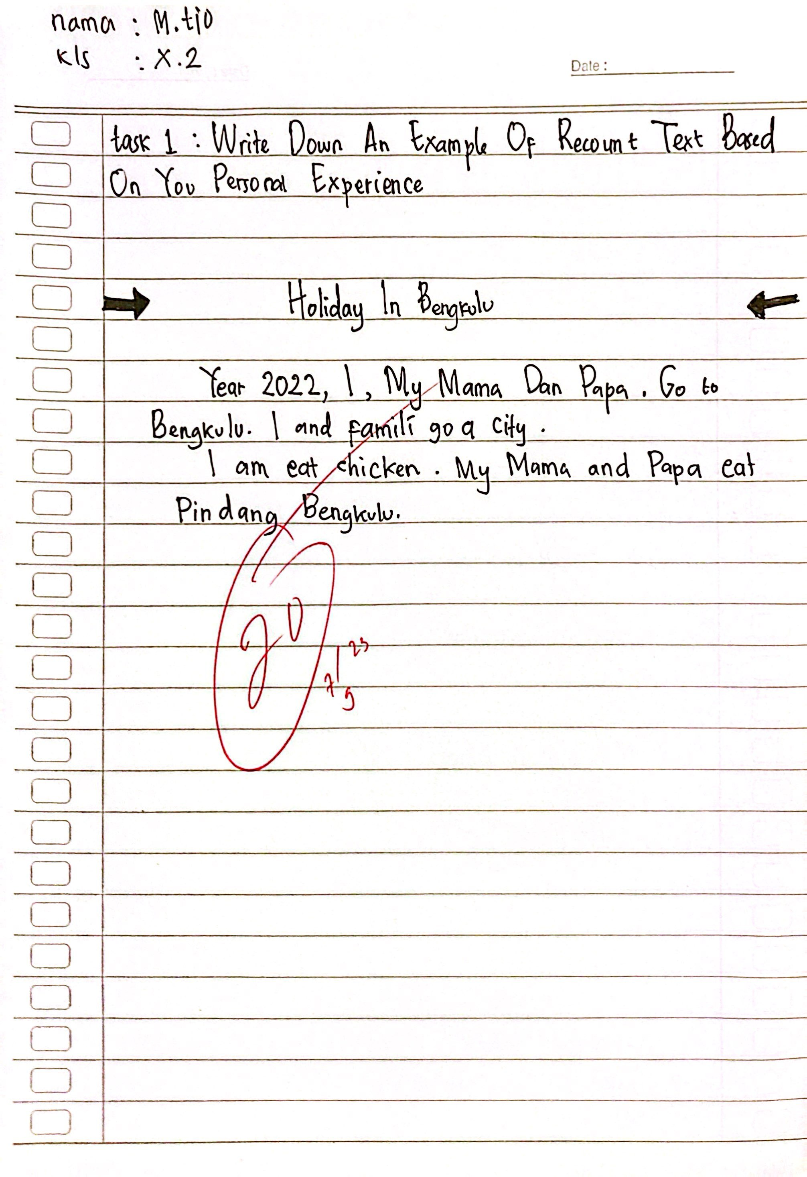

Source : Students’ Writing Assignment (MT)
From the interview and documentation, it can be identified that the students did not know how to use simple past tense and they have problems or difficulties. From interview and supported by documentation result, the students had difficulty in grammatical mastery, especially simple past tense. The students had difficulties in using the past simple verbs such as in determining or putting past verb after the subject, the students felt confuse in decided the correct verbs for each subject.
- 2. Discussion
After collecting the data, the researcher analyzed them and the researcher found that the students difficulties in writing recount text. Based on the findings of data analysis by applying thematic analysis, there were several difficulties faced by students of Class X SMA Bina Warga 2 Palembang in writing recount text. Those were consisted: lack of vocabulary mastery, lack of generating the generic structure of recount text and lack of grammatical mastery.
In this study, there were some difficulties that happened after the students writing recount text. The first difficulty was the students’ lack of vocabulary mastery. The students claimed that they did not have enough vocabulary so that they did not have idea to write recount text because of the limitation of vocabulary. It is supported by Alisha (2019) who stated that the most significant problems are lack of vocabulary and they are difficult to develop their ideas and to put their ideas in an appropriate sentences. It is make students feel difficult when they write recount text. It is in line with Sari’s (2017) findings that indicated the students still have problems in vocabulary mastery, they did not have many vocabularies in their mind, so they can not share their ideas into a good sentence. Then, when we compare it with the study by Yulianawati (2018) it was found that the problem does not only lie in vocabulary but also lies in the idea of students who have difficulty when writing recount texts. Also, because of lack of vocabulary the students use the same words in different context.
The second difficulty was the students had difficulty in understanding in generating generic structure. This happened because the students experienced difficulties in developing the sequence when writing recount text cause by students were confused to develop a logical sequence of events. Therefore, in writing recount text students have difficulty with events because lack of understanding of this part of the events. This result was supported by Supatmi (2013) who argued that the students faced difficulties while writing in the part of the generic structure in the recount text. Then, it is in line with the research that was conducted by Husna and Multazim (2019), they argued that students still have difficulties in making it orientation, events and re-orientation. When we compare with research from Februansyah (2020), it was found that not all students have difficulties with all text structures; only three texts were found that did not meet the criteria: some texts are not clearly in the part of the event, a text has no reorientation, and the last is no setting in the orientation stage.
The third difficulties was the grammatical mastery. This difficulty occurred because the students did not understand the past form of the verbs, what personal pronoun to use, what a linking verb is, and how to use it. In addition, the students were not familiar with the contextual use of the simple past form because they were confused to change the verbs. The result of this study was supported by Fitriyani (2019) who stated that the students have difficulties in making good and correct sentences, which are related to grammar when writing recount text because most of the students do not pay attention to the use of grammar and correct word order. This is in line with the research findings by Salawazo et al. (2020), who stated that students have poor ability to use simple past tense. students do not know grammar in simple past tense. They did not know how to use the tenses. When we compare it with the study by Mustafa (2021), it turns out that the problem does not only lie in past tense but also lies in choosing the right verb form. In this study, students still use infinitive verbs to write recount texts, whereas they should use past verbs.
In conclusion, this study sheds light on several key difficulties faced by students in writing recount texts. Firstly, a notable challenge is the lack of vocabulary mastery, hindering students' ability to articulate their ideas effectively. Secondly, students struggle with generating a coherent generic structure, encountering difficulties in organizing events logically within their narratives. Lastly, grammatical mastery poses a significant hurdle, as students grapple with past tense forms, pronoun usage, and sentence structure. Addressing these challenges through targeted instruction and practice can greatly enhance students' proficiency in crafting compelling recount texts.

CHAPTER V

CONCLUSION AND SUGGESTION
This chapter presents (1) conclusion and (2) suggestion.

5.1. Conclusions
The aim of this research was to find out the students' difficulties in writing recount text at SMA Bina Warga Palembang. The participants of this research were the first grade students of X.2 and X.8 at SMA Bina Warga 2 Palembang. This research focused on analyzing difficulties in writing recount text at SMA Bina Warga 2 Palembang. Based on the findings, the researcher found that there were three factors, lack of vocabulary, lack of understanding in generating generic structure of recount text and lack of grammatical mastery .
Based on the research did by the researcher in line with the desired goal, it can be concluded that students have difficulties in writing recount text: the first difficulty is lack of vocabulary mastery. The students had difficulties in producing the words. The second is lack of understanding in generating generic structure of recount text. Most of the students had difficulties in developing ideas and in arranging the words in producing paragraph. And the third is lack of grammatical mastery. Most of students had problems in arranging words into a good order in recount text. And the last, the students had difficulties in using the second verbs such as in determining or putting verb 2 after the subject, the students felt confuse in deciding the correct verb for each subject. The main faced by the students is in mastering writing recount text was in arranging the words, developing idea, and using simple past tense.

5.2. Suggestions
Based on the discussions and conclusions, the researcher gives some
Suggestions as follows:

- English teacher: the teachers are hoped to update the teaching writing material, especially in writing recount text. And then teacher must prepare the method with the students’ needs, so it can make the students enjoy the teaching learning class.
- The students: the researcher suggested the students to study harder about recount text in order to gain more knowledge. It will be better for the students to read more in order to exchange their knowledge.
- The next researcher: the researcher hopes this research will be a reference for the feature researcher to do the better study.

References

Alfiyah, A. M. (2021). An analysis of students' errors in writing recount text.
Amanda, R., Ilma.,R & Desvitasari.,D. (2024). Investigating the difficulties on students' writing recount text. Professional journal of English education.
https://doi.org?10.29407/jsp.v6i1.229

Alisha, F., Safitri, N., Santoso, I., & Siliwangi,I. (2019). Students' difficulties in writing. Professional journal of English education, 2(1). http://dx.doi.org/10.22460/project.v2il.p20-25

Algeo, J. (2010). The origins and development of the English language (6th ed.).
Cengage Learning.

Amberg, J. S., & Vause, D. J. (2009). American English : History, structure, and usage (1st ed.). Cambridge University Press.

Anderson, M., & Anderson, K. (1998). Text types in English 3. Educational PTYLTD.

Brown, H. D. (2001). Teaching by principles. an interactive approach to language pedagogy. Longman, 2.

Choudhury, M. (2013). Teaching culture in EFL : Implications, challenges and strategies. IOSR Journal of Humanities and Social Science, 13(1). https://doi.org/10.9790/0837-1312024

Creswell, J. W. (2012). Research design : Qualitative, quantitative and mixed methods approaches. SAGE Publication.

David P. Harri. (1996). Testing English as a second language. MC Graw Hill.

Februansyah., V (2020) an analysis of students’ difficulties in writing recount texts. English Education and Applied Linguistics Journal (EEAL Journal) 3(2):98-106 https://doi.org.10.31980/eealjournal.v3i2.1837

Fitriyani, P. (2019) The effect of using chain writing method on students’ writing performance of recount text. repository.uinjkt.ac.id

Gerot, L., & Wignel, P. (1994). Making sense of functional grammar (1st ed.).
Antipodean Educational Enterprise.
Granville, Kate. (2001). Writing from Start to Finish: A Six Step Guide. Published by Griffin Press. ISBN 1 86508 514 6.
Harmer, J. (2001) The Practice of English Language Teaching. 4th Edition
Harmer, J. (2003) How to teach English. Longman.
Harmer, J. (2004). How to teach writing. Pearson Educational limited.

Harmer, J. (2007). The practice of English language teaching. Longman.
Harris, P, David. (1996) Testing English as a second language. Megrawa Hill

Harris, A. (2014). An analysis of students' difficulties in writing recount text at tenth grade of SMAN 1 sungai limau. Journal English Language Teaching (ELT), p1-14 https://ejournal.unp.ac.id/index.php/elt/article/view/4567

Hermawan, B. (2022). Bahasa Inggris : Work in progress. Pusat Perbukuan Kemendikbud & Kemenristekdikti.

Hinkel, E. (2004). Teaching academic ESL writing : Practical techniques in vocabulary and grammar. Lawrence Erlbarum Associates Publishers.

Hossain, M. I. (2015). Teaching productive skills to the students : A secondary scenario. BRAC University.

Husna, A., & Multazim, A. (2019) Students’ difficulties in writing recount text at inclusion classes. LET: Linguistics, Literature and English Teaching Journal 9(1) https://doi.org/10.18592/let.v9i1.3077

Hyland, K. (2010). Second language writing. Cambridge university press. https://doi.org/10.1017/CBO9780511667251

Indriyani, R. (2013). A genre analysis of the difficulties in writing descriptive text by the students of class VIII SMP N 2 Kartasura in 2012 / 2013 academic year. eprints.ums.ac.id.

Kuzel, A. J. (1992). Sampling in qualitative inquiry. SAGE Publication.
Miner, D., & Zitnay, J. (2012). Exploring nonfiction with young learners.
Rowman & Littlefield Education.

Mustafa, F. (2021) The use of past tense verbs and adverbs in students' recount texts. INFERENCE: Journal of English Language Teaching 4(1) http://dx.doi/10.30998/inference.v4i2.6002

Nunan, D. (2003). Practical English language teaching (1st ed.). MC Graw Hill Company.

Purnomo, A. (2023). An analysis of students' difficulties in writing narrative text in class x sma al-azhar syifa budi solo academic year 2022/2023. https://eprints.iain-surakarta.ac.id/id/eprint/7249

Rahmah, L. S. (2017). Improving student's score in writing descriptive text through think talk write strategy. International Journal of English and Education, 6(4), 180-193. www.ijee.org

Sari, M. K. (2017). An analysis of students problem in writing recount text. JURNAL EDUCATIVE : Journal of Educational Studies 2(1), 15-22.
https://doi.org/10.24036/jelt.v9i3.109227

Salawazo (2020) Analysis of students difficulties in writing recount text 4(1)
E-ISSN : 2598-2877 https://doi.org/10.28926/riset_konseptual.v4i1.171

Sarwono, J. (2006). Metode penelitian kuantitatif dan kualitatif. Graha Ilmu.

Setiyadi, B. (2006) Metode penelitian untuk pengajaran bahasa asing. Graha Ilmu
Sudarwati, M., & Grace, E. (2014) Pathway to English : for senior high school grade XI. Erlangga

Supatmi, D. (2013). Students difficulties in writing recount text at the second year of SMPN 2 Kartasura in 2012/2013 academic year. Publication Journal of School of Teacher Training of Education Muhammadiyah University of Surakarta.
Sugiyono. (2009). Metode penelitian kuantitatif, ualitatif dan R&D. Alfa Beta Bandung.

Thomas, B. (2022). The role of purposive sampling technique as a tool for informal choices in a social sciences in research methods. Just Agriculture, 2(5), 3-10. DOI:10.17348/era.5.0.147-158

Wardiman, A. (2008). English in focus 2 : for grade junior high school.
Bengawan Ilmu.

Yin, R. K. (2018). Case study research and applications : Design and methods.
SAGE Publication

Yulianawati. (2018). An Analysis of Students’ Difficulties in Writing Recount Text ( A Case Study at a Senior High School in Indramayu). English Focus, 2(1) DOI:10.24905/efj.v2i1.48

INTERVIEW GUIDELINE

Students’ Difficulties in Writing Recount Text at SMA Bina Warga 2 Palembang

Indicators | Sub Indicators | Description | Interview Questions
- Idea and Vocabulary | Getting idea & Vocabulary | According to Linse (2005) Vocabulary is the collection of words that an individual knows. Then, Dorow (2015) stated that Ideas are essential for organizations because they are the source of innovation, which is a never- ending source of competitive  advantage. | - When you write a recount text, don't you ever feel like you have no ideas or don't know what to write? You no longer know what to write? Please explain!  - In your opinion, do you have enough / decent English vocabulary to write a recount text ? for example to write about your last holiday.

2. Generic Structure | Orientation | The reader of a recount text is told who was involved, what happened, where the event occurred, and when it occurred. | - What do you know about orientation in writing recount text? please explain !  - What do you think about your ability in writing orientation of recount text?  - Do you have any problem in writing orientation of recount text? Please explain !
 | Events | A series of event that are ordered or arranged chronologically | - What do you know about events in writing recount text? Please explain!  - What do you think about your ability in writing events of recount text?  - Do you find it difficult to write series of events in  recount text? Please explain!
 | Re-orientation | The story's ending. In other words, this is a type of prose that describes how something happened in the past chronologically as well as the feelings associated with that event. | - What do you know about re-orientation in writing recount text?  10. What do you think about your ability in writing re- orientation of recount text?  11. Do you find it difficult while writing recount text especially in the re-orientation part? Please explain!

3.Language Features | Personal Pronoun | I , we, you, he, she, it, they are called personal pronouns because they stand for three persons (i) the person speaking (ii) the person spoken to, and  (iii) the person spoken of | 12. Are you familiar with personal pronouns? Can you please tell me about it?  13. in your opinion, what is the function of personal pronoun?  14. Do you have difficulties in determining personal  Pronoun and how to use it? Please describe in detail!
 | Linking Verb | A linking verb connects the subject of a sentence to an adjective, noun, or pronoun that completes the meaning of the verb | - What do you know about linking verb? Can you please explain!  - What do you think about your ability in choosing and using linking verb in recount text?  - Do you have any problems in determining linking verb and how to use it? please describe in detail
 | Action Verb | From "English Grammar and Usage" by Roger Berry:  "Action verbs are verbs that express an action that someone or something does, such as 'run,' 'jump,' 'write,'  'sing,' or 'dance.' | - Do you know what action verb is? Can you please tell me about it?  - Do you have any problems in determining action verbs and when to use it? Please describe in detail !  - Can you tell me some examples of action verbs do you know?

 | Simple Past Tense | From "A Comprehensive Grammar of the English Language" by Randolph Quirk, Sidney Greenbaum, Geoffrey Leech, and Jan Svartvik: "The simple past tense is used to refer to a past time, past habits or states, or past events that are seen as completed. | - What do you know about simple past tense? Please explain!  - What do you think about your ability in using simple past tense in your recount text?  - Are you familiar with the formula of simple past tense?  - Do you have any problems or difficulties when you use verb “be” in nominal simple past tense? Please explain!  - Do you have any problems or difficulties when you use verb “do” in verbal simple past tense? Please explain!

Source : Supatmi (2013)

APPENDIX A
INTERVIEW PROTOCOL

INTRODUCTION PROTOCOL
Good morning. Thank you for giving me this oppurtunity and also your time to this interview. My name is Muhammad Rafli and I am doing my research now. The title of my research is Students’ Difficulties in Writing Recount Text at SMA Bina Warga 2 Palembang. The purpose of my research is to find out the students’ difficulties in writing recount text at SMA Bina Warga 2 Palembang.
TAPE RECORDER INSTRUCTOR
The school was prohibitate the researcher to recording the voice of the interviewee so the researcher took notes for the interviewee respons.

APPENDIX B
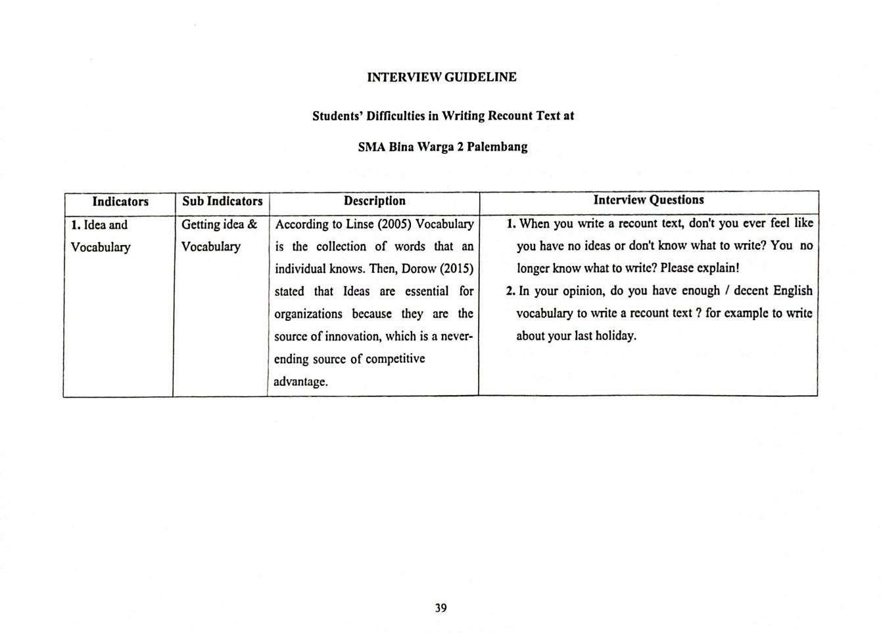
INTERVIEW INDICATOR

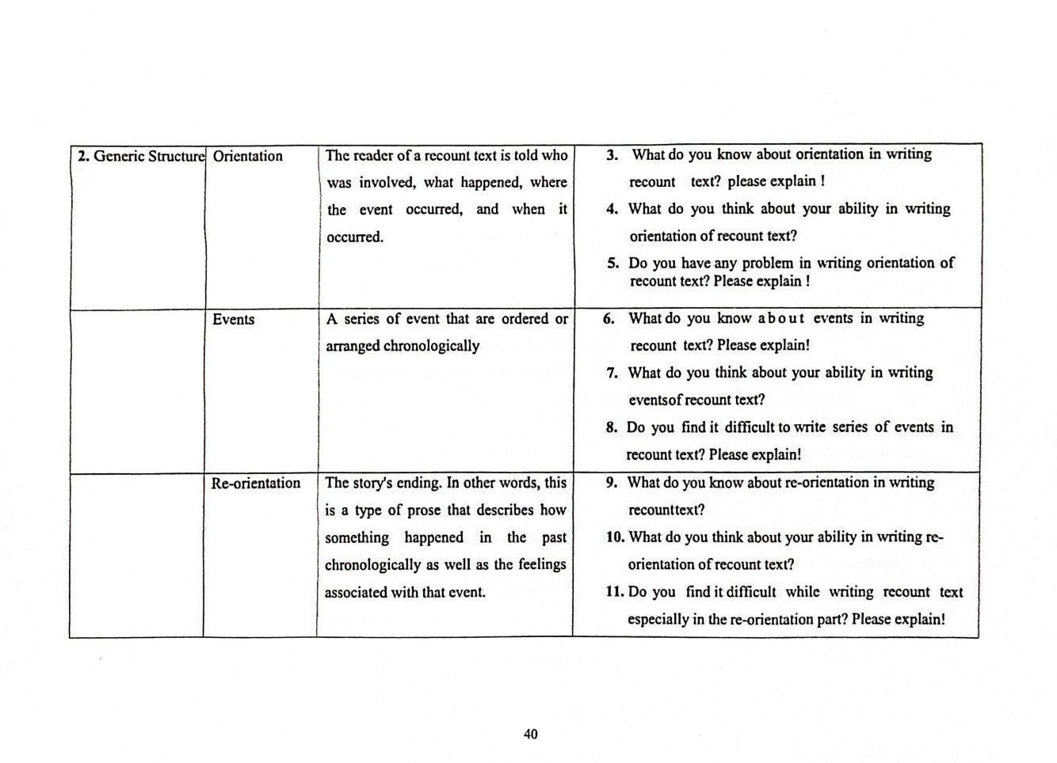

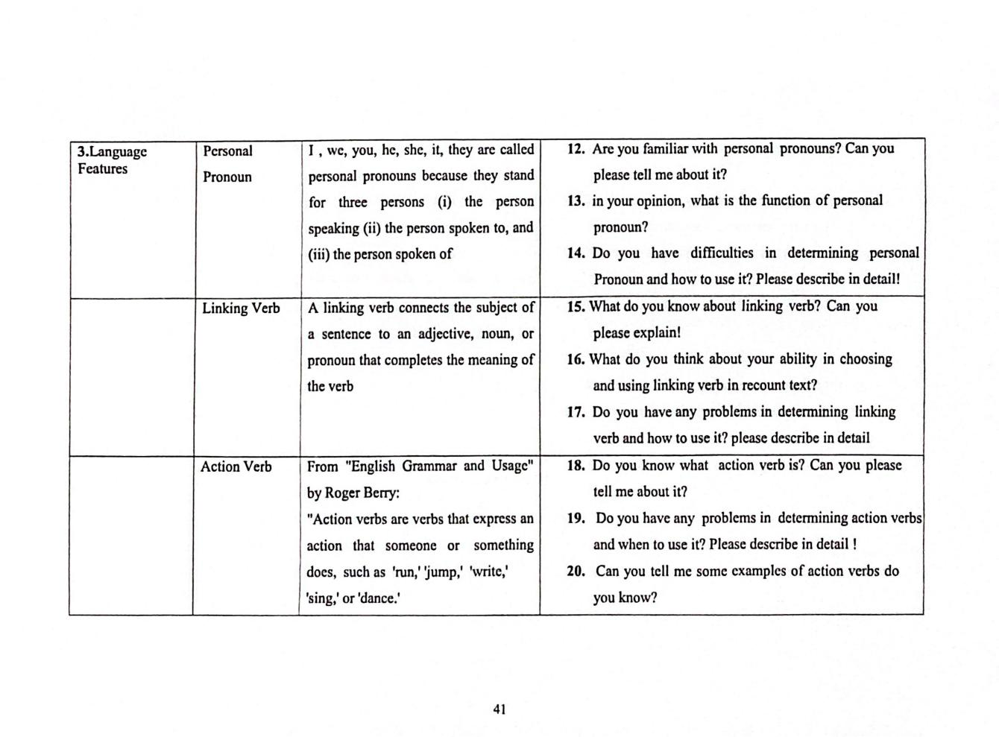

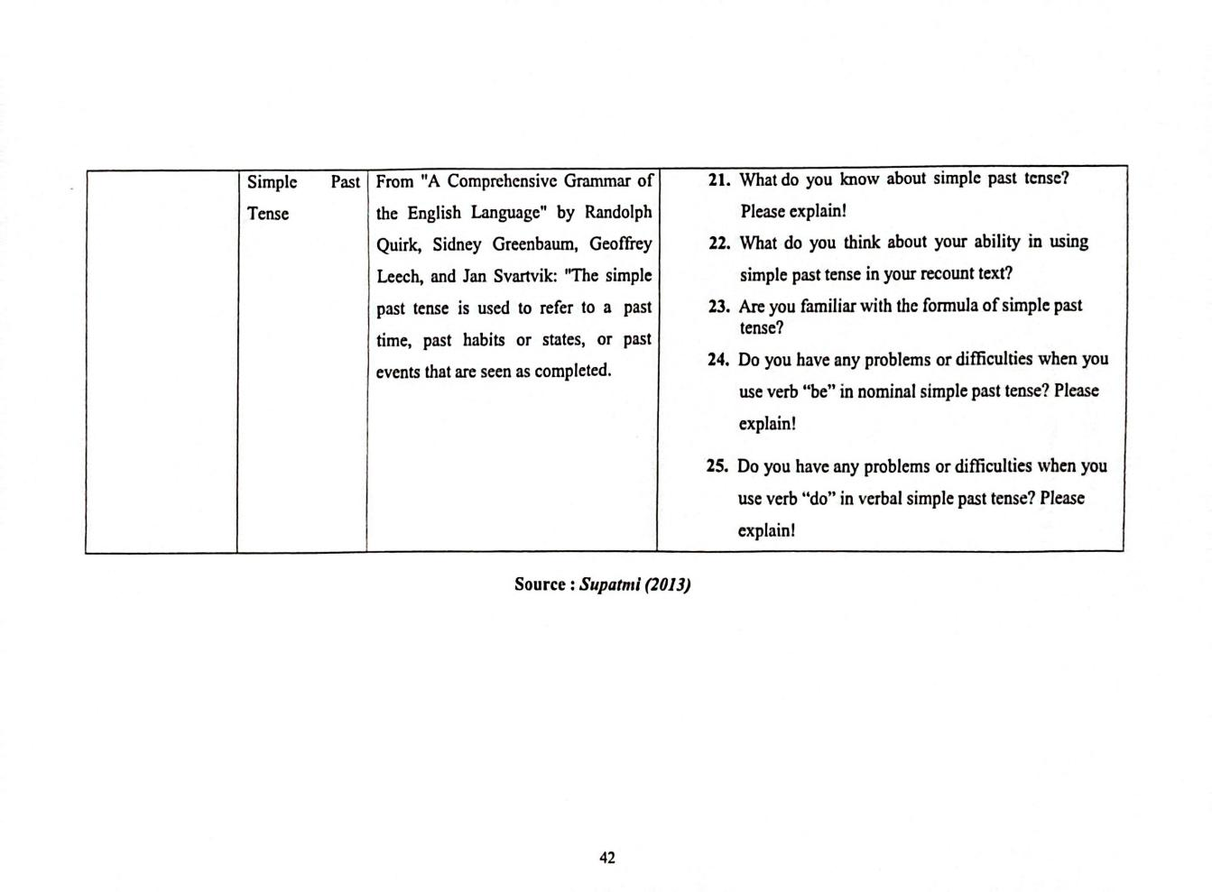

APPENDIX C
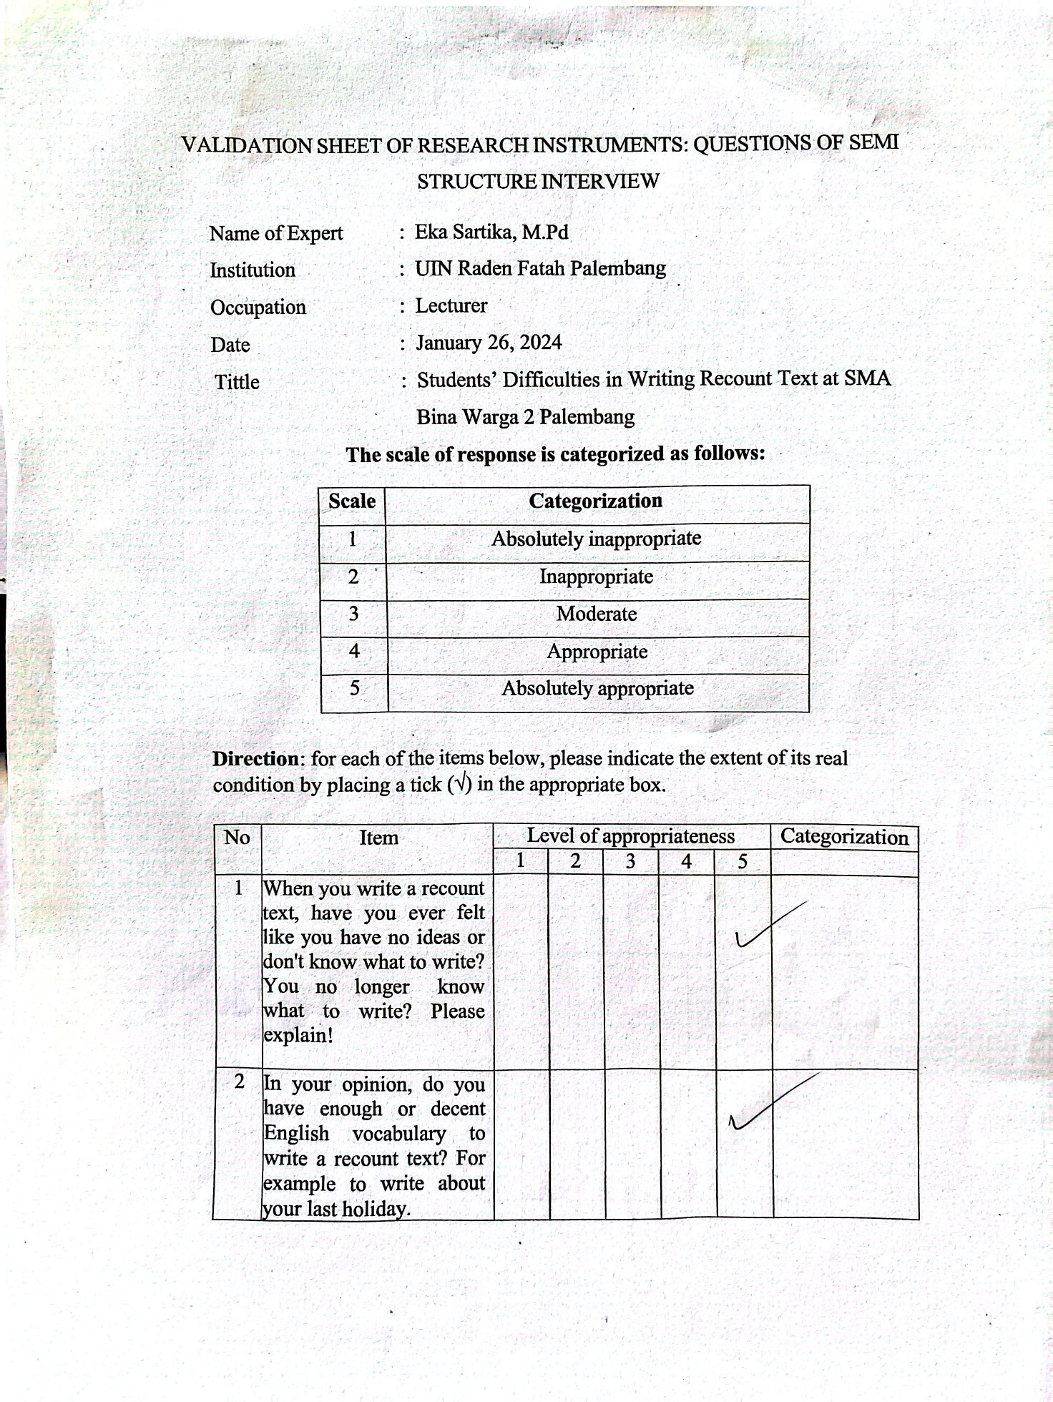
VALIDATION SHEET OF RESEARCH INSTRUMENT

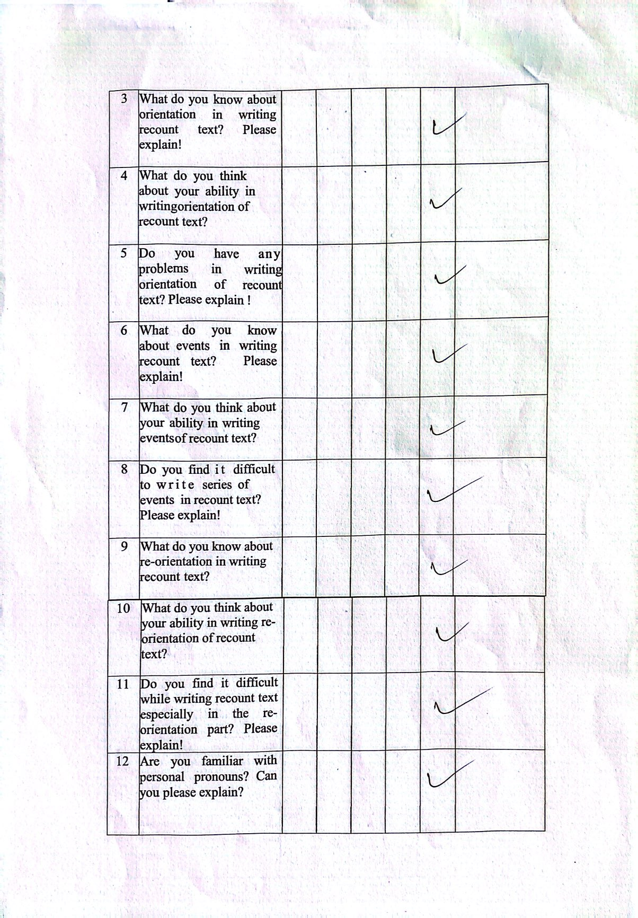

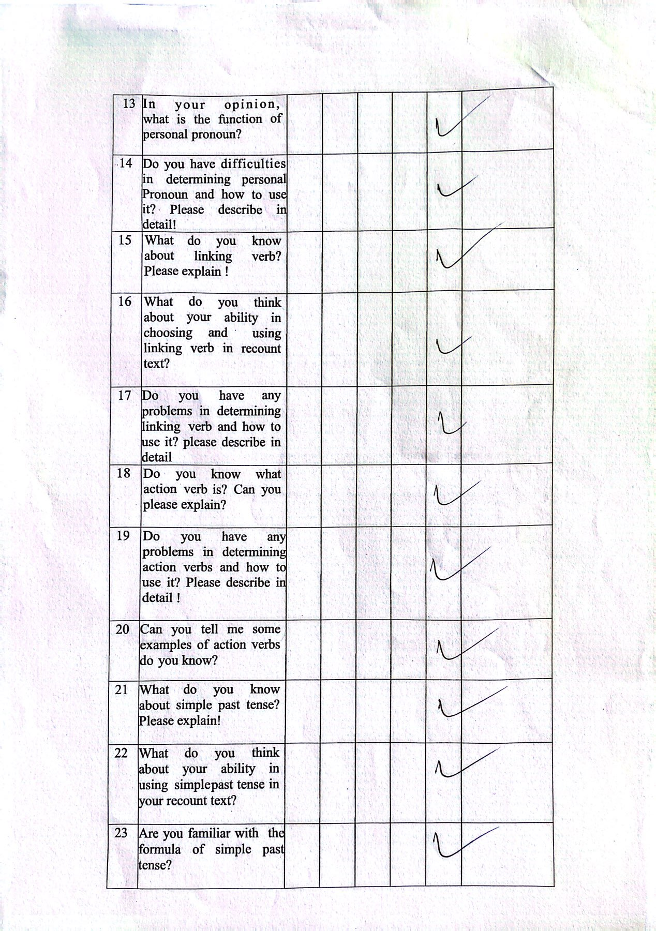

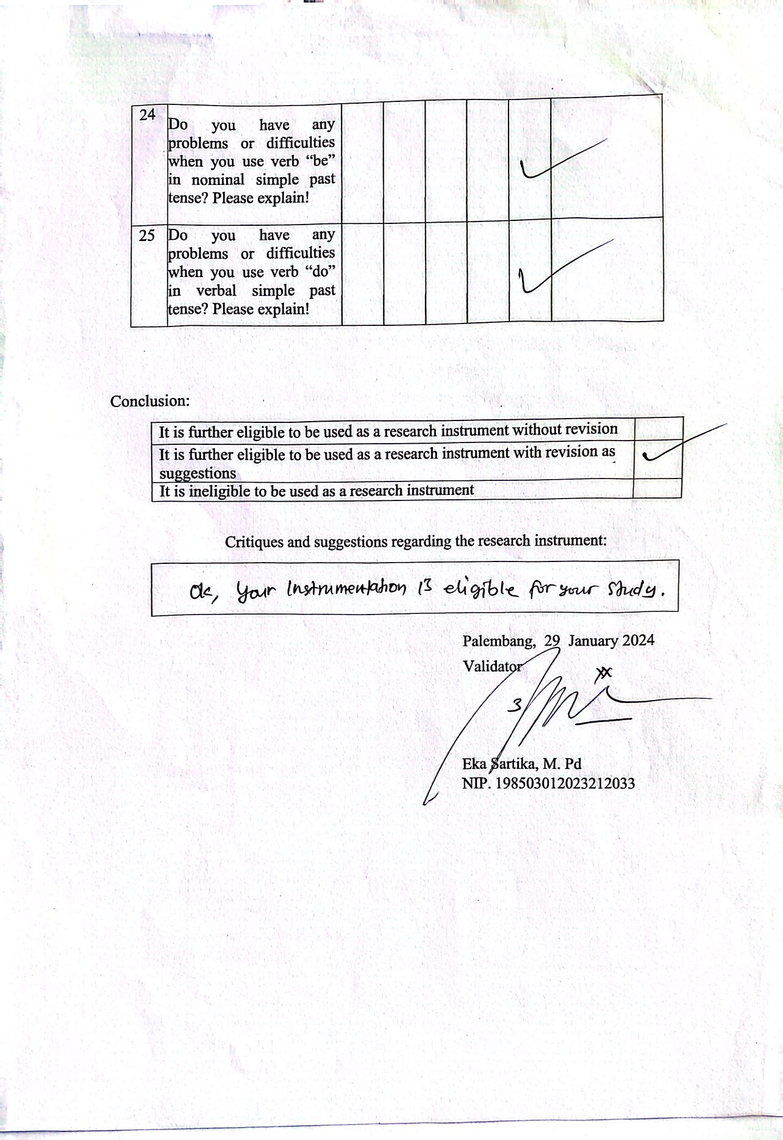

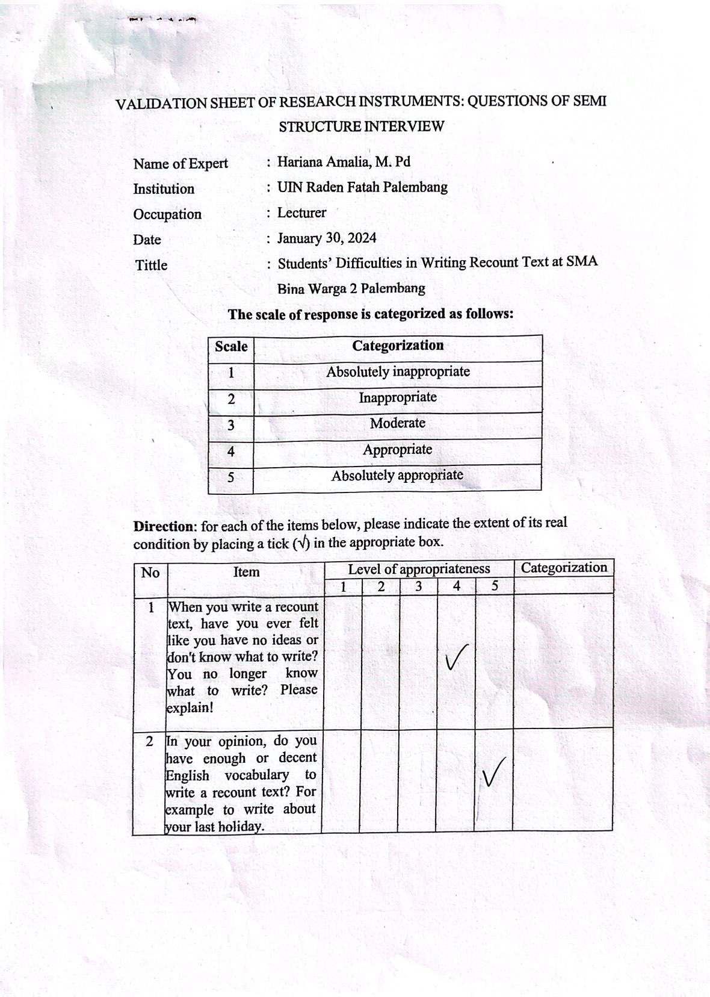

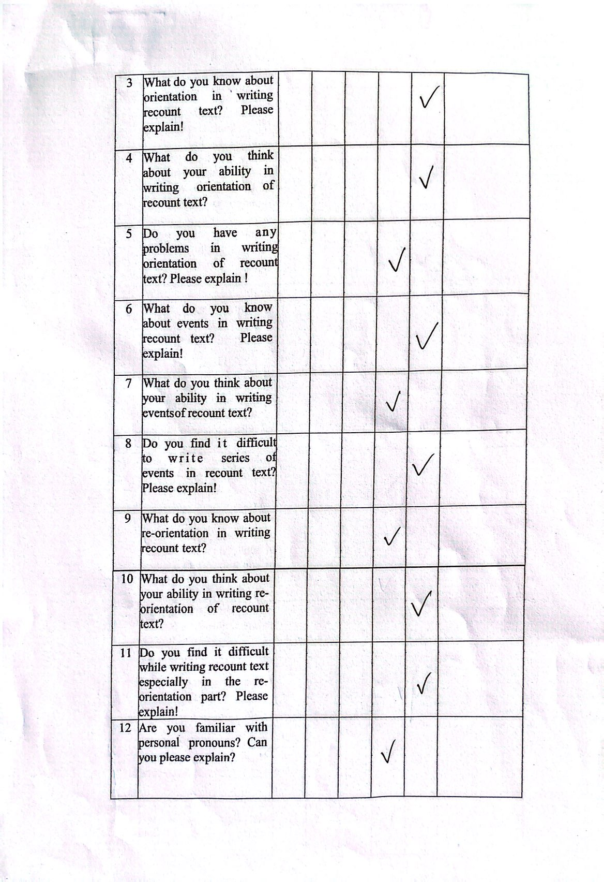

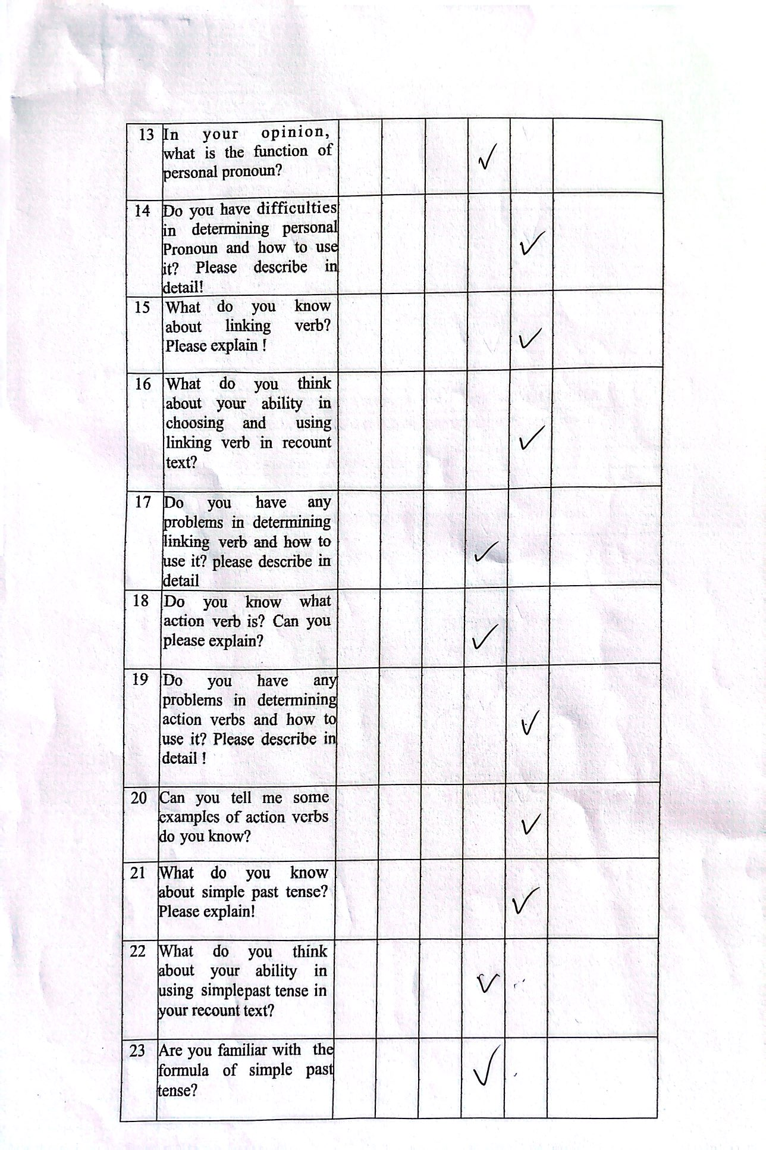

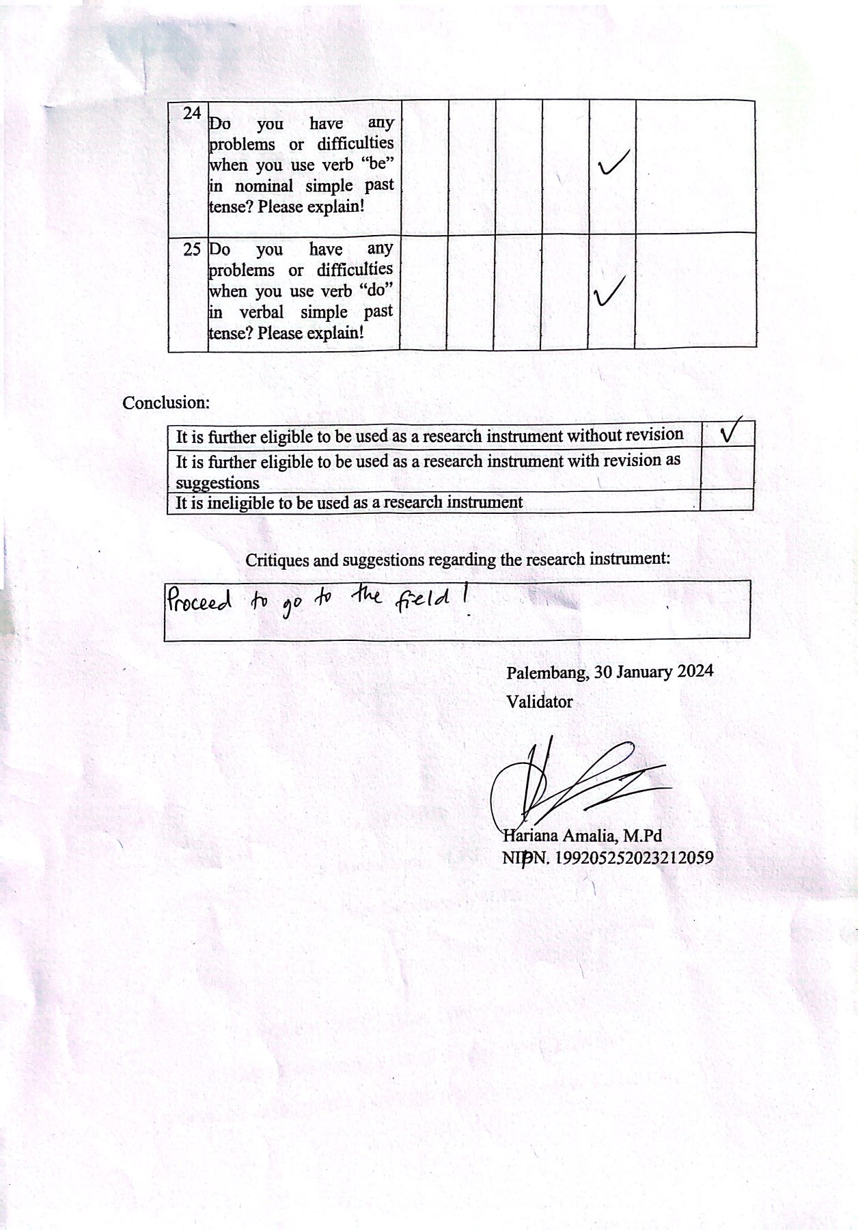

APPENDIX D
INTERVIEW TRANSCRIPTION RESULT

Researcher : Muhammad Rafli
NIM : 2020205022
Title : Students’ Difficulties in Writing Recount Text at SMA Bina Warga 2 Palembang
Interviewee : Initial S.R
Status : First Grade Students at SMA BW 2 Palembang

Researcher : Good morning.
Interviewee : Morning, Sir.
Researcher : How are you today?
Interviewee : Alhamdulillah, I’m good.
Researcher : I’d like to interview you, wouldn’t you?
Interviewee : Yes, Sir.
Researcher : When you write a recount text, have you ever felt like you have no ideas or don’t know what to write? You no longer know what to write? Please explain!
Interviewee : Yes. I feel like I don’t know what to write because I do not understand the recount text at all and I have not even understood the structure of the text recount.
Researcher : In your opinion, do you have enough or decent English vocabulary to write a recount text? For example, to write about your last holiday.
Interviewee : I think my English vocabulary is not enough to write a recount text. Particularly when I am told to write about my recent vacation, there is a possibility of encountering more complex vocabulary that I might not be familiar with.
Researcher : What do you know about orientation in writing recount text? Please explain!
Interviewee : I am aware that the orientation serves as the beginning of the text, but I am unsure about the specific content that should be included within that section.
Researcher : What do you think about your ability in writing orientation of recount text?
Interviewee : I think I don’t really understand the concept of orientation in this context. I am uncertain about the appropriate information to include in the opening section of a recount text.
Researcher : Do you have any problems in writing orientation of recount text? Please explain!
Interviewee : Yes, I do. I don’t understand the process of writing and structuring paragraphs within the introduction due to the perceived difficulty. Consequently, when attempting the introduction, I solely focus on narrating the story, leading to confusion.
Researcher : What do you know about events in writing recount text? Please explain!
Interviewe : While I recognize the concept of “events” as the core happenings of the narrative, I lack the knowledge required to effectively write them.
Researcher : What do you think about your ability in writing events of recount text?
Interviewee : Honestly, I believe my current capabilities are inadequate for composing a compelling account of the events within the recount.
Researcher : Do you find it difficult to write series of events in recount text? Please explain!
Interviewee : Yes, I had difficulty when writing the sequence of events. Due to the lack of clarity on required content, I was left feeling confused and unable to construct a coherent paragraph within this section.
Researcher : What do you know about re-orientation in writing recount text?
Interviewee : My interpretation is that the re-orientation serves as a means of summarizing the recount.
Researcher : What do you think about your ability to write re-orientation recount texts?
Interviewee : I feel like I don’t have the ability to write re-orientation because there are so many aspects to write.
Researcher : Do you have any difficulties writing recount text, especially in the re-orientation section? Please explain!
Interviewee : In my personal opinion, the most challenging aspect lies in combining personal reflections and conclusions within the re-orientation section, as instructed by the teacher.
Researcher : What do you know about linking verb? Please explain!
Interviewee : My current understanding suggests that linking verbs simply function as verbs.
Researcher : What do you think about your ability in choosing and using linking verb in recount text?
Interviewee : I don’t think I’m capable of using the linking verbs because I myself do not know what linking verbs are.
Researcher : Do you have any problems in determining linking verb and how to use it? please describe in detail
Interviewee : My primary challenge lies in the lack of familiarity with the concept and application of linking verbs. Furthermore, I am unsure about their function within sentences and how to recognize them.
Researcher : Do you know what action verb is? Can you please explain?
Interviewee : I don’t know much about action verb, but I think that action verb indicates action.
Researcher : Do you have any problems in determining action verbs and how to use it? Please describe in detail!
Interviewee : Yeah, I’ve had a problem, particularly when attempting to explain the actions conveyed within sentences.
Researcher : Can you tell me some examples of action verbs do you know?
Interviewee : My knowledge in this area is limited. The only verbs I can readily identify are “eat” and “drink.”
Researcher : What do you know about simple past tense? Please explain!
Interviewee : Similar to the simple present tense, my understanding of the simple past tense is that it represents a grammatical structure used to narrate past events in English.
Researcher : What do you think about your ability in using simple past tense in your recount text?
Interviewee : I’m less capable of using simple past tense because I can’t make
a good recount text so it’s possible I won’t be able to use simple past tense.
Researcher : Are you familiar with the formula of simple past tense?
Interviewee : No, I’m not. I’ve studied it, but I forgot all the formulae.

Researcher : Do you have any problems or difficulties when you use verb “be” in nominal simple past tense? Please explain!
Interviewee : Yes, I experience difficulties due to my lack of understanding regarding the proper usage of “was” and “were” within the simple past tense.
Researcher : Do you have any problems or difficulties when you use verb “do” in verbal simple past tense? Please explain!
Interviewee : Yes, I do. I also don’t know much English verbs so I find it hard for me to effectively utilize verbs within the simple past tense structure.
Researcher : Thank you very much. The interview is over.
Interviewee : Alright, you are welcome, Sir.

TRANSCRIPT OF INTERVIEW RESULT

Researcher : Muhammad Rafli
NIM : 2020205022
Title : Students’ Difficulties in Writing Recount Text at SMA Bina Warga 2 Palembang
Interviewee : Initial M.T
Status : First Grade Students at SMA BW 2 Palembang

Researcher : Good morning.
Interviewee : Morning, Sir.
Researcher : How are you today?
Interviewee : I am good.
Researcher : I’d like to interview you, is it okay? Interviewee : Yes, it is.
Researcher : When you write a recount text, don’t you ever feel like you have no ideas or don’t know what to write? You no longer know what to write? Please explain!
Interviewee : Yes, I don’t have a suitable a suitable topic and develop ideas for a recount text because I’m not familiar with the concept itself.
Researcher : In your opinion, do you have enough / decent English vocabulary to write a recount text ? for example to write about your last holiday.
Interviewee : For example, about the holidays. I don’t think I have a lot of vocabulary I might only be able to manage basic words like “one day”.
Researcher : What do you know about orientation in writing recount text? Please explain!
Interviewee : All I know about the orientation is the opening and introductory story of the character.
Researcher : What do you think about your ability in writing orientation of recount text?
Interviewee : I believe my skills are still lacking in this area because I don’t fully grasp the concept of recount texts.
Researcher : Do you have any problem in writing orientation of recount text? Please explain!
Interviewee : Yes, Sir. I have problem in introducing the characters in a recount text. Sometimes I find it difficult to properly introduce them at the beginning.
Researcher : What do you know about events in writing recount text? Please explain!
Interviewee : As I know event is that held by a company or producer.
Researcher : What do you think about your ability in writing events of recount text?
Interviewee : I don’t fully understand the concept of events within a recount text.
Researcher : Do you find it difficult to write series of events in recount text? Please explain!
Interviewee : Yes, I find writing the events section very challenging. I struggle to organize my sentences and express the events clearly due to limited English vocabulary.
Researcher : What do you know about re-orientation in writing recount text? Interviewee : I don’t know, Sir.
Researcher : What do you think about your ability in writing re-orientation of recount text?
Interviewee : I don’t know how to distinguish between orientation and re-orientation. So, I guess I can’t afford to write recount text.
Researcher : Do you find it difficult while writing recount text especially in the re-orientation part? Please explain!
Interviewee : Yes, I find writing the re-orientation difficult because they seem to have different meanings. I often get them confused and use them interchangeably.
Researcher : Are you familiar with personal pronouns? Can you please tell me about it?
Interviewee : Yeah, I’m pretty good at using people’s nickname with the sign: and “
Researcher : In your opinion, what is the function of personal pronoun?
Interviewee : I think it’s a pronoun to distinguish speakers from others.

Researcher : Do you have difficulties in determining personal pronoun and how to use it? Please describe in detail!
Interviewee : I find it difficult to choose the correct pronoun because I get confused about which one to use in a particular context.
Researcher : What do you know about linking verb? Can you please explain!
Interviewee : No, I can’t. The term itself is new to me. However, I understand that a verb, if used correctly, is simply a verb.
Researcher : What do you think about your ability in choosing and using linking verb in recount text?
Interviewee : I’m confused because I have no knowledge of linking verbs in English.
Researcher : Do you have any problems in determining linking verb and how to use it? Please describe in detail.
Interviewee : I don’t understand how to use this linking verb, Sir.
Researcher : Do you know what action verb is? Can you please tell me about it?
Interviewee : I don’t know what an action verb is, sir, but I know that a verb is a verb.
Researcher : Do you have any problems in determining action verbs and when to use it? Please describe in detail!
Interviewee : I don’t understand action verbs, how they are used, or in what sentence structures they appear. The concept of action verbs confuses me.
Researcher : Can you tell me some examples of action verbs do you know?
Interviewee : I’ve never heard of action verbs before.
Researcher : What do you know about simple past tense? Please explain!
Interviewee : I remember that the simple past tense is used to talk about the past.
Researcher : What do you think about your ability in using simple past tense in your recount text?
Interviewee : I’m unsure. I recall that the past tense uses verb 2, but I can’t remember the specific verb conjugations.
Researcher : Are you familiar with the formula of simple past tense?
Interviewee : I was taught the formula in high school, sir, but unfortunately, I’ve forgotten it.
Researcher : Do you have any problems or difficulties when you use verb “be” in nominal simple past tense? Please explain!
Interviewee : Yes, I sometimes get confused and misuse “was” and “were.”
Researcher : Do you have any problems or difficulties when you use verb “do” in verbal simple past tense? Please explain!
Interviewee : My problem is that I don’t remember and lack knowledge of English verbs in general. This leads to confusion when I try to write the correct verb in the simple past tense.
Researcher : Thank you very much, the interview is over.
Interviewee : Anytime, Sir.

TRANSCRIPT OF INTERVIEW RESULT

Researcher : Muhammad Rafli
NIM : 2020205022
Title : Students’ Difficulties in Writing Recount Text at SMA Bina Warga 2 Palembang
Interviewee : Initial N.A
Status : First Grade Students at SMA BW 2 Palembang

Researcher : Good morning.
Interviewee : Morning, Sir.
Researcher : How are you today?
Interviewee : Alhamdulillah, I’m good today, Sir.
Researcher : I’d like to interview you, wouldn’t you?
Interviewee : Yes, Sir.
Researcher : When you write a recount text, don’t you ever feel like you have no ideas or don’t know what to write? You no longer know what to write? Please explain!
Interviewee : I have trouble writing the recount text due to the initial hurdle of selecting a specific story to narrate.
Researcher : In your opinion, do you have enough / decent English vocabulary to write a recount text ? For example, to write about your last holiday.
Interviewee : It seems that I don’t think I have enough and decent vocabulary in a recount text writing. It is due to I myself can’t translate words into English.
Researcher : What do you know about orientation in writing recount text? Please explain
Interviewee : I am unfamiliar with the specific concept of “orientation” within the context of recount texts. My understanding is that recount texts are primarily structured using paragraphs.
Researcher : What do you think about your ability in writing orientation of recount text?
Interviewee : I lack the necessary skills to effectively write the orientation section of a recount text.

Researcher : Do you have any problem in writing orientation of recount text? Please explain!
Interviewee : Yes, I have a problem when writing the orientation due to my limited understanding of the concept and the process of constructing an appropriate paragraph.
Researcher : What do you know about events in writing recount text? Please explain!
Interviewee : Honestly, I don’t know what events are and the required sentence structure within this section.
Researcher : What do you think about your ability in writing events of recount text?
Interviewee : In my opinion, my abilities are insufficient for effectively conveying the sequence of events within a recount text. I’m not even able to formulate coherent sentences and organize the events in a logical manner.
Researcher : Do you find it difficult to write series of events in recount text? Please explain!
Interviewee : Yes, I experience significant difficulty in organizing and presenting the sequence of events in a clear and grammatically correct manner.
Researcher : What do you know about re-orientation in writing recount text?
Interviewee : Same as paragraph event, I once learned about the recount text structure is the same miss **** but I don’t understand and confused about this re-orientation.
Researcher : What do you think about your ability in writing re-orientation of recount text?
Interviewee : I can’t write re-orientation because I find it very difficult. Also, I’m confused what I have to write on this section.
Researcher : Do you find it difficult while writing recount text especially in the re-orientation part? Please explain!
Interviewee : I feel difficult because I don’t know how to write or make a good and correct sentence especially on this re-orientation part.
Researcher : Are you familiar with personal pronouns? Can you please tell me about it?
Interviewee : I’m not used to hearing personal pronouns. I just hear it from you; now this is probably also something I’ve studied, but I forgot.
Researcher : In your opinion, what is the function of personal pronoun?
Interviewee : I’m sorry, Sir. I myself don’t know the function of personal pronouns that you have mentioned.
Researcher : Do you have difficulties in determining personal pronoun and how to use it? Please describe in detail!
Interviewee : Yes, I encounter challenges in determining pronouns and their appropriate usage within the context of a recount text.
Researcher : What do you know about linking verb? Can you please explain!
Interviewee : I don’t know at all.
Researcher : What do you think about your ability in choosing and using linking verb in recount text?
Interviewee : I feel I don’t have a good ability to use this linking verb because I myself do not have an extensive knowledge about it.
Researcher : Do you have any problems in determining linking verb and how to use it? Please describe in detail!
Interviewee : I have trouble using the linking verb because I’m unfamiliar with the concept of linking verbs and don’t recall the specific verbs themselves.
Researcher : Do you know what action verb is? Can you please tell me about it?
Interviewee : Honestly, I’m not sure what action verbs are, and I wouldn’t be able to explain them.
Researcher : Do you have any problems in determining action verbs and when to use it? Please describe in detail!
Interviewee : Yes, due to my limited knowledge of action verbs, I get confused and struggle to choose the correct ones for my recount texts.
Researcher : Can you tell me some examples of action verbs do you know?
Interviewee : Unfortunately, I can’t recall any specific action verbs in English at this time.
Researcher : What do you know about simple past tense? Please explain!
Interviewee : I’m so sorry, Sir, but I can’t remember what the simple past tense is.
Researcher : What do you think about your ability in using simple past tense in your recount text?
Interviewee : It seems like I may have learned it at some point, but I don’t feel comfortable using the simple past tense. I believe my ability is still weak.
Researcher : Are you familiar with the formula of simple past tense?
Interviewee : No, I don’t remember the formula.
Researcher : Do you have any problems or difficulties when you use verb “be” in nominal simple past tense? Please explain!
Interviewee : I’m sorry, Sir, but I’m not sure what this is or how to use it.
Researcher : Do you have any problems or difficulties when you use verb “do” in verbal simple past tense? Please explain!
Interviewee : I don’t understand the concept of verbal verbs in the simple past tense, and I haven’t memorized verbs in English.
Researcher : Well, that was the interview. Thank you for the answer and the time.
Interviewee : You’re welcome. I’m happy to help you, Sir.

TRANSCRIPT OF INTERVIEW RESULT

Researcher : Muhammad Rafli
NIM : 2020205022
Title : Students’ Difficulties in Writing Recount Text at SMA Bina Warga 2 Palembang
Interviewee : Initial N.M
Status : First Grade Students at SMA BW 2 Palembang
Researcher : Good morning
Interviewee : Morning, Sir.
Researcher : How are you today?
Interviewee : Alhamdulillah.
Researcher : I’d like to interview you, wouldn’t you?
Interviewee : Sure.
Researcher : When you write a recount text, don’t you ever feel like you have no ideas or don’t know what to write? You no longer know what to write? Please explain!
Interviewee : Yes, for two main reasons. First, I don’t have enough ideas to get started. Second, I lack the vocabulary to express myself clearly.
Researcher : In your opinion, do you have enough / decent English vocabulary to write a recount text ? For example, to write about your last holiday.
Interviewee : I don’t believe my English vocabulary is strong enough for writing tasks. Sometimes I struggle to find the correct words to express myself.
Researcher : What do you know about orientation in writing recount text? Please explain!
Interviewee : I don’t know very well about orientation but as I recall orientation is the opening paragraph.
Researcher : What do you think about your ability in writing orientation of recount text?
Interviewee : In my opinion, my ability to write the orientation section is still below average.
Researcher : Do you have any problem in writing orientation of recount text? Please explain!
Interviewee : Yes, I do. The problem is I’m unsure of proper writing techniques.

Researcher : What do you know about events in writing recount text? Please explain!
Interviewee : If I’m not mistaken the meaning of event is the same as an event. I’m confused to explain the meaning of the events section.
Researcher : What do you think about your ability in writing events of recount text?
Interviewee : I do not have a good ability to write paragraphs on recount text because I struggle to connect sentences and express myself clearly due to limited vocabulary.
Researcher : Do you find it difficult to write series of events in recount text? Please explain!
Interviewee : Yes, I find it difficult to sequence events in English.
Researcher : What do you know about re-orientation in writing recount text? Interviewee : Perhaps it refers to repeating a word for emphasis
Researcher : What do you think about your ability in writing re-orientation of recount text?
Interviewee : I believe my overall ability in recount writing is still low.
Researcher : Do you find it difficult while writing recount text especially in the re-orientation part? Please explain!
Interviewee : Yes, this section seems to be the most challenging. I was told by Ms. **** that it requires including specific details, and I struggle with how to organize them.
Researcher : Are you familiar with personal pronouns? Can you please tell me about it?
Interviewee : I’m not accustomed to using personal pronouns effectively in my writing.
Researcher : In your opinion, what is the function of personal pronoun?
Interviewee : Sorry, Sir. I don’t know the function of personal pronoun.
Researcher : Do you have difficulties in determining personal Pronoun and how to use it? Please describe in detail!
Interviewee : Yes, I have difficulty in determining personal pronouns because I don’t understand their purpose in a sentence.
Researcher : What do you know about linking verb? Can you please explain! Interviewee : Sorry, I don’t know about linking verbs in sentences or text.

Researcher : What do you think about your ability in choosing and using linking verb in recount text?
Interviewee : Since I don’t understand linking verbs at all, I believe I have no ability to choose or use them correctly in my writing.
Researcher : Do you have any problems in determining linking verb and how to use it? Please describe in detail
Interviewee : The problem is that I simply don’t understand linking verbs and how to use them.
Researcher : Do you know what action verb is? Can you please tell me about it? Interviewee : No, I don’t. I’m not familiar with the term “action verb.”
Researcher : Do you have any problems in determining action verbs and when to use it? Please describe in detail!
Interviewee : Yes sir I have a problem in this because I haven’t memorized verbs and don’t know how to use them in sentences.
Researcher : Can you tell me some examples of action verbs do you know?
Interviewee : I don’t know, Sir.
Researcher : What do you know about simple past tense? Please explain!
Interviewee : I’m unfamiliar with the simple past tense and how to use it in recount writing.
Researcher : What do you think about your ability in using simple past tense in your recount text?
Interviewee : Actually, I have studied with friends but I still don’t understand. I don’t believe I’m proficient in using it in my writing.
Researcher : Are you familiar with the formula of simple past tense?
Interviewee : I’ve heard of the simple past tense, but I’m not familiar with the specific formula. It seems difficult.
Researcher : Do you have any problems or difficulties when you use verb “be” in nominal simple past tense? Please explain!
Interviewee : I don’t know how to use “was” and “were” correctly in the simple past tense. I’m unsure of the rules for choosing between them.
Researcher : Do you have any problems or difficulties when you use verb “do” in verbal simple past tense? Please explain!
Interviewee : Yes, because I don’t fully understand how to use verbs in the simple past tense in general.
Researcher : Well, that was the interview. Thank you for your answers and time.
Interviewee : Thank you, Sir. I will study more.

TRANSCRIPT OF INTERVIEW RESULT

Researcher : Muhammad Rafli
NIM : 2020205022
Title : Students’ Difficulties in Writing Recount Text at SMA Bina Warga 2 Palembang
Interviewee : Initial A.A
Status : First Grade Students at SMA BW 2 Palembang

Researcher : Good morning
Interviewee : Morning, Sir.
Researcher : How are you today?
Interviewee : Alhamdulillah, Sir.
Researcher : Would you be willing I interview you?
Interviewee : Yes, Sir, I’d be happy to.
Researcher : When you write a recount text, don’t you ever feel like you have no ideas or don’t know what to write? You no longer know what to write? Please explain!
Interviewee : I used to, sir, because I myself felt lazy when I was told to write a recount text. In the end, I had no idea sir and was also confused about what to write.
Researcher : In your opinion, do you have enough / decent English vocabulary to write a recount text ? For example, to write about your last holiday.
Interviewee : I don’t think so, Sir, because I don’t remember
Researcher : What do you know about orientation in writing recount text? Please explain!
Interviewee : I only know that this orientation is a recount text structure.
Researcher : What do you think about your ability in writing orientation of recount text?
Interviewee : I feel like I don’t have the skills in that field.
Researcher : Do you have any problem in writing orientation of recount text? Please explain!
Interviewee : Yes, I have difficulty in writing the orientation. It is because I can’t do it.

Researcher : What do you know about events in writing recount text? Please explain!
Interviewee : I’m sorry, Sir, just like the orientation, I only know that events are the structure of this text.
Researcher : What do you think about your ability in writing events of recount text?
Interviewee : I am not good at recount writing, especially this section.
Researcher : Do you find it difficult to write series of events in recount text? Please explain!
Interviewee : Yes, I find it very difficult to write a series of events in a recount text because I don’t know what words to write in that section.
Researcher : What do you know about re-orientation in writing recount text? Interviewee : Sorry, I don’t know, Sir. But it might be similar to orientation.
Researcher : What do you think about your ability in writing re-orientation of recount text?
Interviewee : I feel like I don’t have the skills in that field.
Researcher : Do you find it difficult while writing recount text especially in the re-orientation part? Please explain!
Interviewee : Obviously, Sir. Because I myself cannot write a good and correct recount text and it is definitely wrong the whole paragraph, I am confused to arrange the sentences of each paragraph.
Researcher : Are you familiar with personal pronouns? Can you please tell me about it?
Interviewee : Sorry, I don’t know for sure.
Researcher : In your opinion, what is the function of personal pronoun?
Interviewee : Probably to tell the reader about the names of the characters.
Researcher : Do you have difficulties in determining personal pronoun and how to use it? Please describe in detail!
Interviewee : Yes, I find it difficult when determining personal pronouns because I don’t know what the personal pronouns are.
Researcher : What do you know about linking verb? Can you please explain! Interviewee : I don’t know about linking verb. I only know about verb.
Researcher : What do you think about your ability in choosing and using linking verb in recount text?

Interviewee : I don’t think my skills are good because I don’t memorize the linking verbs.
Researcher : Do you have any problems in determining linking verb and how to use it? Please describe in detail.
Interviewee : Yes, because I am not able to determine the linking verbs and I also don’t know how to use them.
Researcher : Do you know what action verb is? Can you please tell me about it?
Interviewee : A verb is a word that shows activity, but if it’s an action verb I don’t understand it.
Researcher : Do you have any problems in determining action verbs and when to use it? Please describe in detail!
Interviewee : Sorry, Sir, I don’t understand how to insert and specify this verb into the text.
Researcher : Can you tell me some examples of action verbs do you know?
Interviewee : I’m not sure, sir. Is “go” considered an action verb? That’s the only one I can think of right now.
Researcher : What do you know about simple past tense? Please explain!
Interviewee : As I recall simple past tense is one of the tenses in English that tells an event.
Researcher : What do you think about your ability in using simple past tense in your recount text?
Interviewee : In junior high school, I used to be able to change sentences into the simple past tense by adding plus and minus signs or question marks. However, I’ve forgotten the specifics.
Researcher : Are you familiar with the formula of simple past tense? Interviewee : Yes, sir, but I’ve forgotten it.es sir, but I forgot.
Researcher : Do you have any problems or difficulties when you use verb “be” in nominal simple past tense? Please explain!
Interviewee : The problem seems to be that I forgot how to put “were” in this past tense sentence.
Researcher : Do you have any problems or difficulties when you use verb “do” in verbal simple past tense? Please explain!

Interviewee : I recall something about verb 1 and verb 2. I used to be able to do this, but since I haven’t studied it in a long time, I’ve forgotten how to find the verb 2 for words like “go.” I also remember that the word “do” has a verb 2 form.
Researcher : Well, that concludes the interview. Thank you for the answer and time.
Interviewee : Yes, Sir. I am happy to help you.

TRANSCRIPT OF INTERVIEW RESULT

Researcher : Muhammad Rafli
NIM : 2020205022
Title : Students’ Difficulties in Writing Recount Text at SMA Bina Warga 2 Palembang
Interviewee : Initial M.E
Status : First Grade Students at SMA BW 2 Palembang

Researcher : Good morning.
Interviewee : Morning, Sir.
Researcher : How are you today?
Interviewee : I’m fine, Sir.
Researcher : May I interview you, please?
Interviewee : Yes, you may, Sir.
Researcher : When you write a recount text, don’t you ever feel like you have no ideas or don’t know what to write? You no longer know what to write? Please explain!
Interviewee : Yes, I feel that I often lose ideas or don’t know what to write so I find it difficult to create a written work, especially recount text.
Researcher : In your opinion, do you have enough / decent English vocabulary to write a recount text ? for example to write about your last holiday.
Interviewee : Yes, I don’t know much about English vocabulary, and also I don’t know what words I should write about vacation.
Researcher : What do you know about orientation in writing recount text? Please explain!
Interviewee : I’m not entirely sure, but I believe it was covered in junior high school English class.
Researcher : What do you think about your ability in writing orientation of recount text?
Interviewee : I do not have the ability to compose the orientation of recount text because of my confusion. I do not know how to make a correct orientation paragraph.

Researcher : Do you have any problem in writing orientation of recount text? Please explain!
Interviewee : Yes, Sir, I have problems when I am assigned to write recount text in this section and sometimes I wrote carelessly.
Researcher : What do you know about events in writing recount text? Please explain!
Interviewee : I don’t know the definition of the events but I have seen it in the recount text material yesterday.
Researcher : What do you think about your ability in writing events of recount text?
Interviewee : In my personal opinion sir, I am not able to write events in this recount text because I myself do not know how to write good and correct events section.
Researcher : Do you find it difficult to write series of events in recount text? Please explain!
Interviewee : Yes, Sir. Because of my limited vocabulary, I always struggle to organize events, especially in recount texts.
Researcher : What do you know about re-orientation in writing recount text? Interviewee : I don’t understand the concept of re-orientation in recount texts.
Researcher : What do you think about your ability in writing re-orientation of recount text?
Interviewee : Based on my experience yesterday, I don’t think I can identify sentences that belong in the re-orientation section.
Researcher : Do you find it difficult while writing recount text especially in the re-orientation part? Please explain!
Interviewee : Yes, sir. I certainly find it difficult because I’m unsure what the correct structure and content of the re-orientation section should be.
Researcher : Are you familiar with personal pronouns? Can you please tell me about it?
Interviewee : I’m not too familiar with these personal pronouns sir, but I recall reading some personal pronouns include “I,” “you,” “he,” “she,” and “it.”
Researcher : In your opinion, what is the function of personal pronoun?
Interviewee : As far as I know, they are used to indicate who is telling the story.
Researcher : Do you have difficulties in determining personal pronoun and how to use it? Please describe in detail!
Interviewee : It’s not necessarily difficult, but I wouldn’t say it’s easy either. However, I can use the pronoun “I” without any problems.
Researcher : What do you know about linking verb? Can you please explain!
Interviewee : I don’t have a strong understanding of linking verbs. I’ve read about verbs in the dictionary, but I can’t distinguish linking verbs from other types.
Researcher : What do you think about your ability in choosing and using linking verb in recount text?
Interviewee : My ability to choose linking verbs is not good for now because I’m unfamiliar with the specific vocabulary used for them.
Researcher : Do you have any problems in determining linking verb and how to use it? please describe in detail
Interviewee : The problem is that I don’t know which words fall under the category of linking verbs.
Researcher : Do you know what action verb is? Can you please tell me about it? Interviewee : I don’t understand, but I know some verbs.
Researcher : Do you have any problems in determining action verbs and when to use it? Please describe in detail!
Interviewee : It’s possible that I encountered difficulties yesterday while writing the recount text because I forgot the English terms for verbs.
Researcher : Can you tell me some examples of action verbs do you know?
Interviewee : Action verbs are probably like walk, cry, sleep, right sir? That’s what I know.
Researcher : What do you know about simple past tense? Please explain!
Interviewee : I can’t explain it myself, but you taught it yesterday. Maybe if I study again, I’ll remember.
Researcher : What do you think about your ability in using simple past tense in your recount text?
Interviewee : I think simple past tense is complicated. There is a formula.
Researcher : Are you familiar with the formula of simple past tense?

Interviewee : I wouldn’t say I’m completely familiar with it, sir. However, I have been exposed to the concept of simple past tense formulas and sentence structures.
Researcher : Do you have any problems or difficulties when you use verb “be” in nominal simple past tense? Please explain!
Interviewee : Yes sir, I’m having trouble because I don’t understand the term “nominal past tense.”
Researcher : Do you have any problems or difficulties when you use verb “do” in verbal simple past tense? Please explain!
Interviewee : Maybe, yes. Because I myself did not master this nominal and verbal simple past tense. Additionally, I haven’t memorized many verbs, and I’m unsure of which sentences require the simple past tense.
Researcher : Well, that concludes the interview. Thank you.
Interviewee : Anytime, Sir.

APPENDIX E
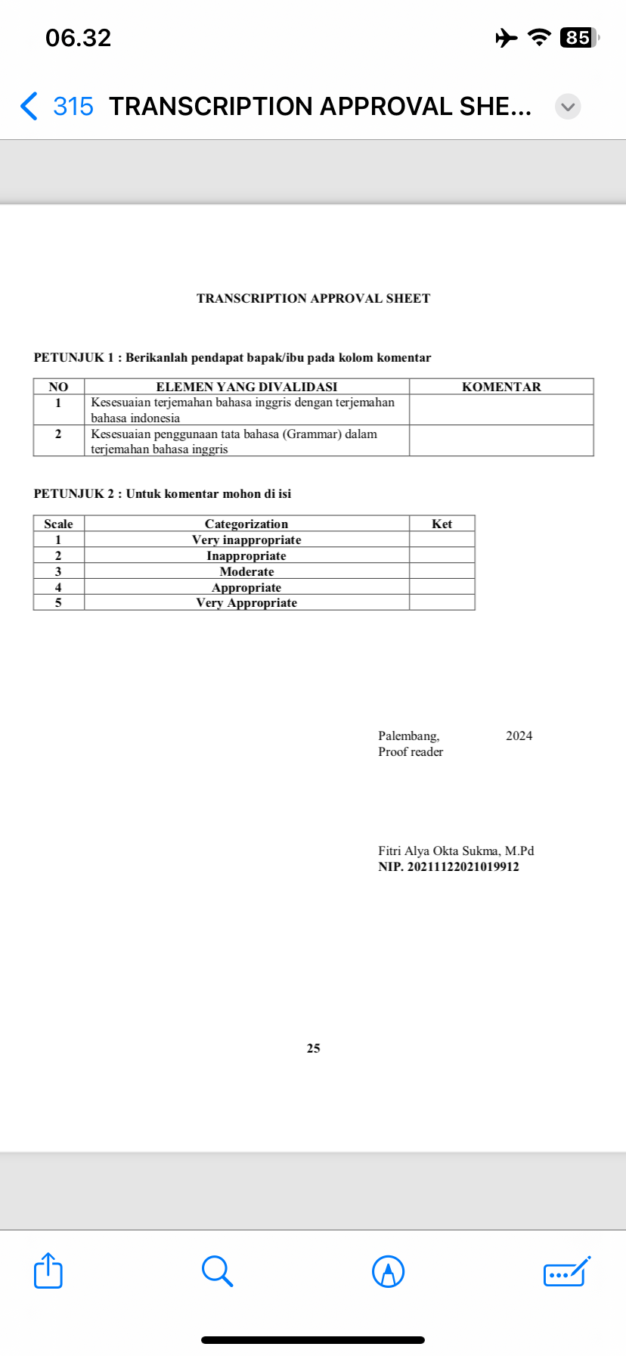
TRANSCRIPTION APPROVAL SHEET

APPENDIX F

DOCUMENTATION
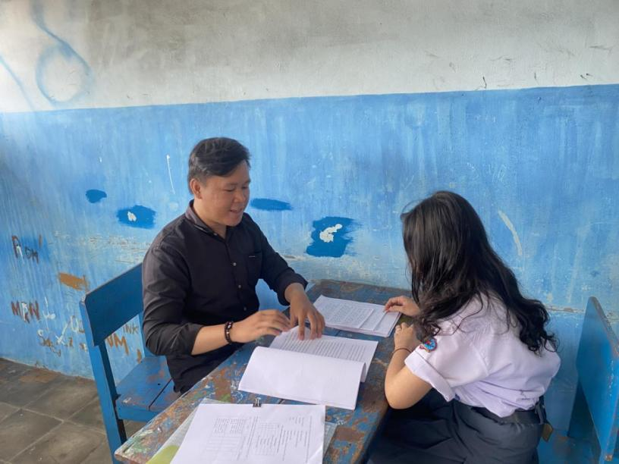

Participant 1

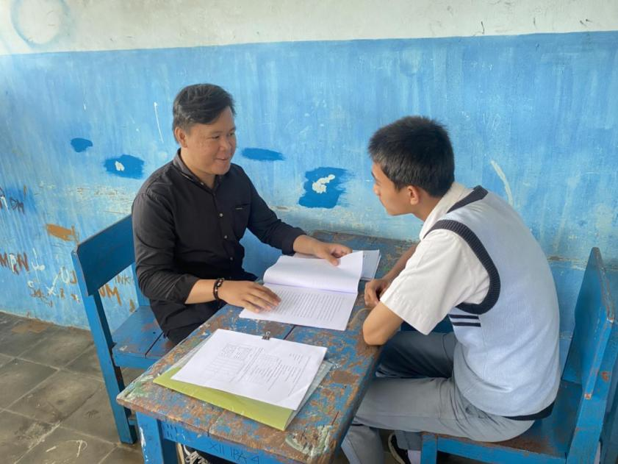

Participant 2

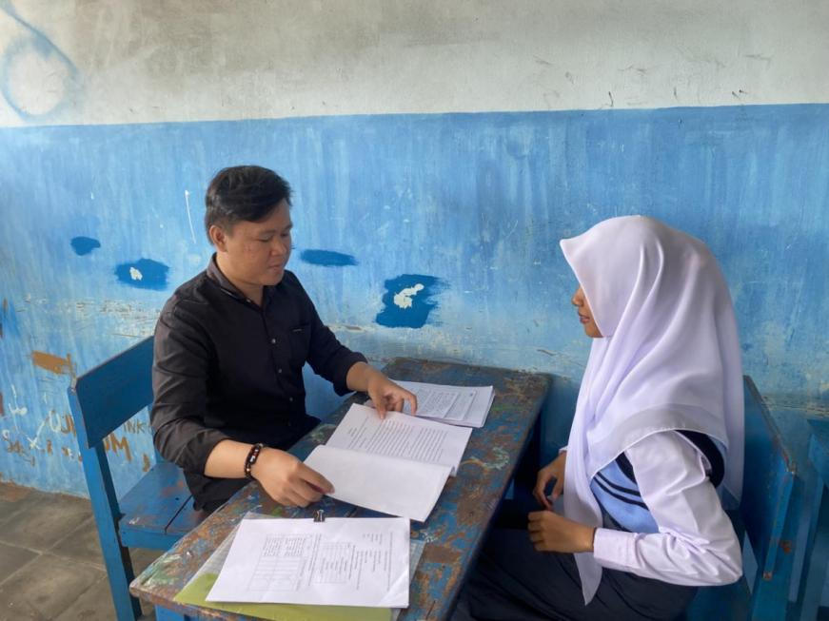

Participant 3

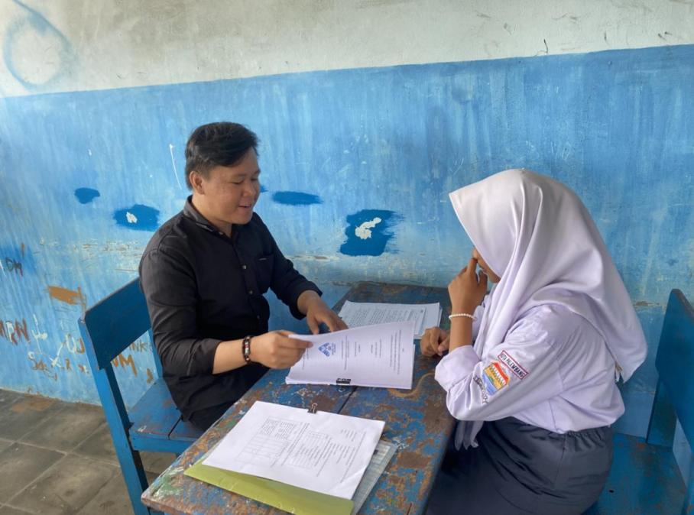

Participant 4

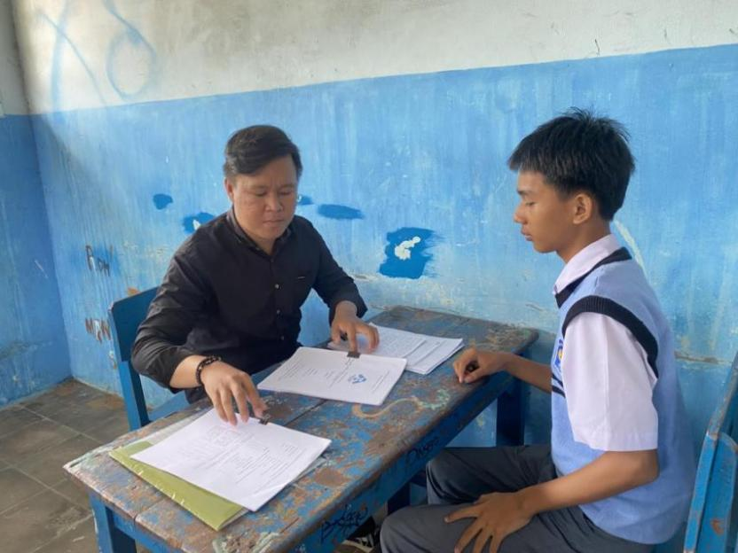

Participant 5

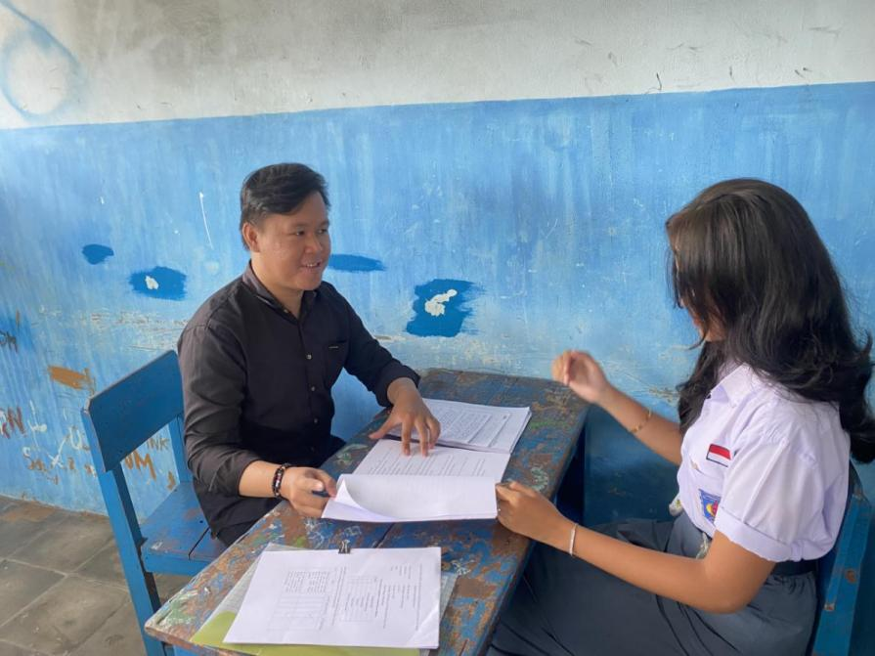

Participant 6

Particuipant 1

Participant 2

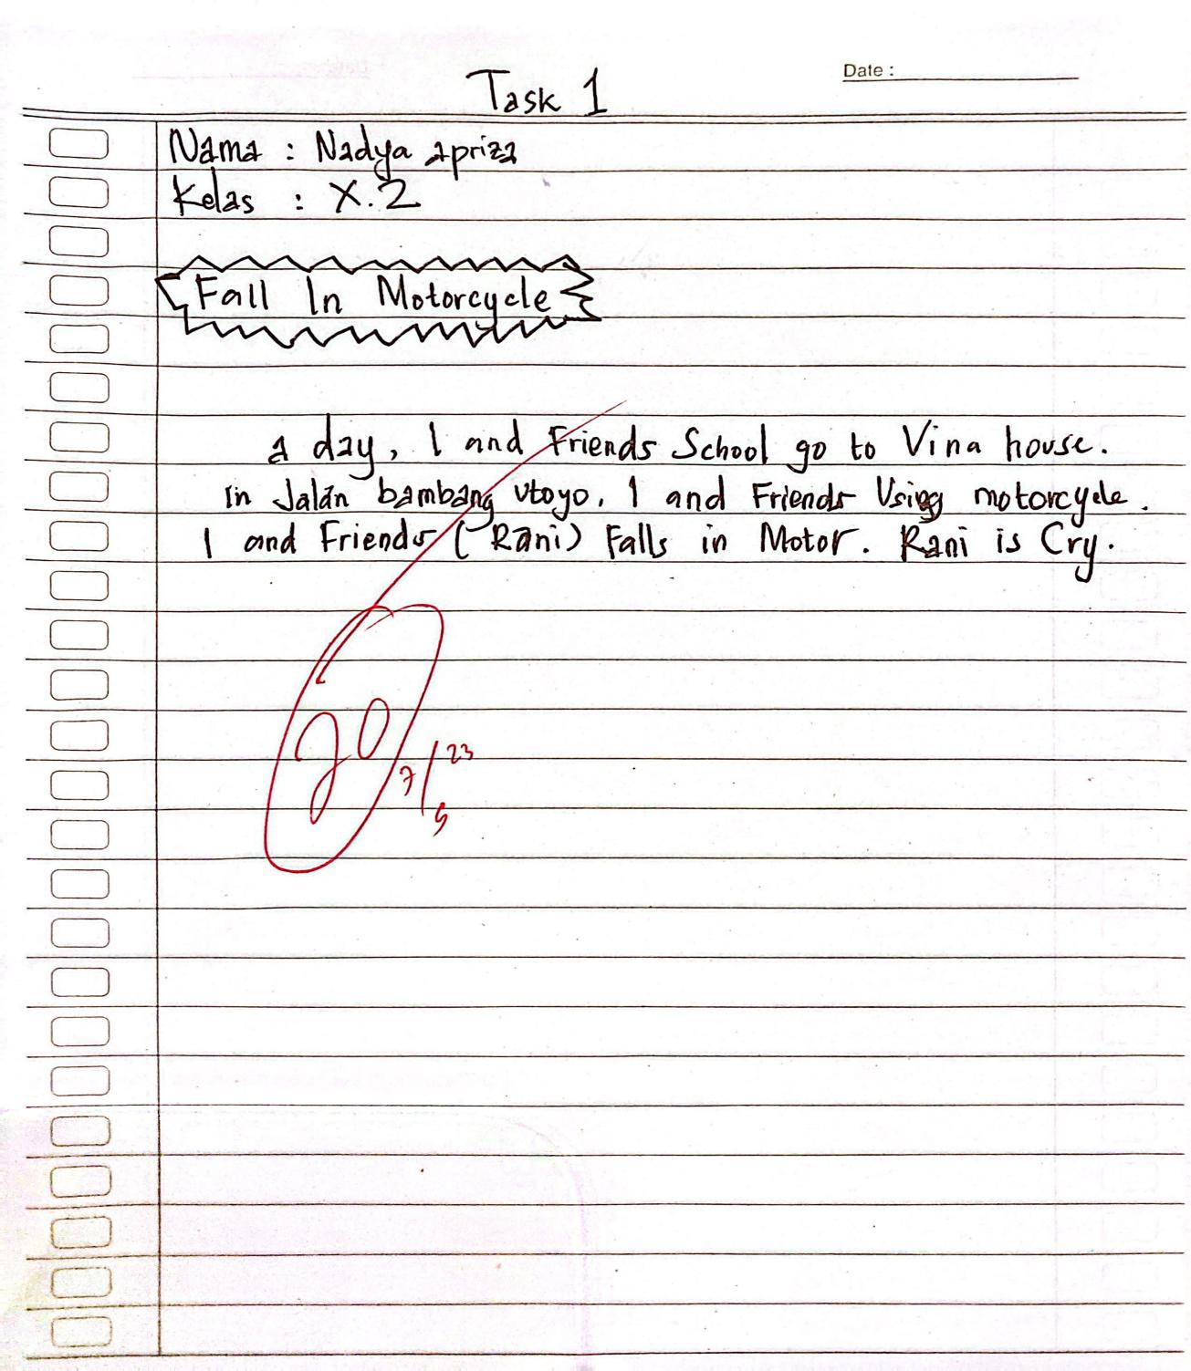

Participant 3
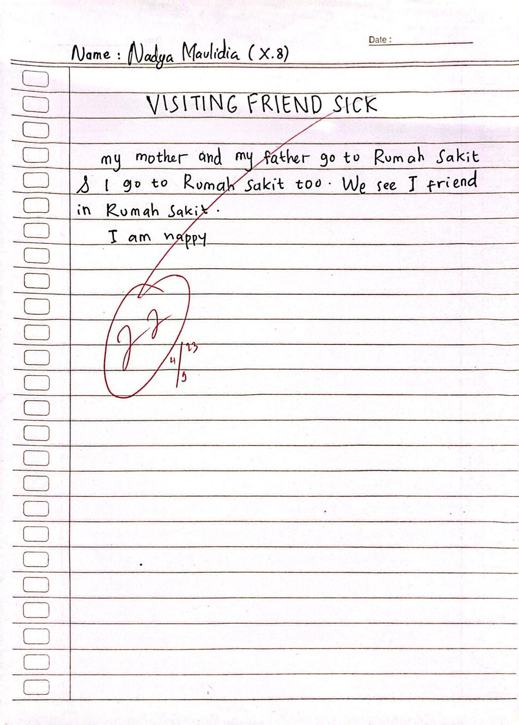

Participant 4

Participant 5

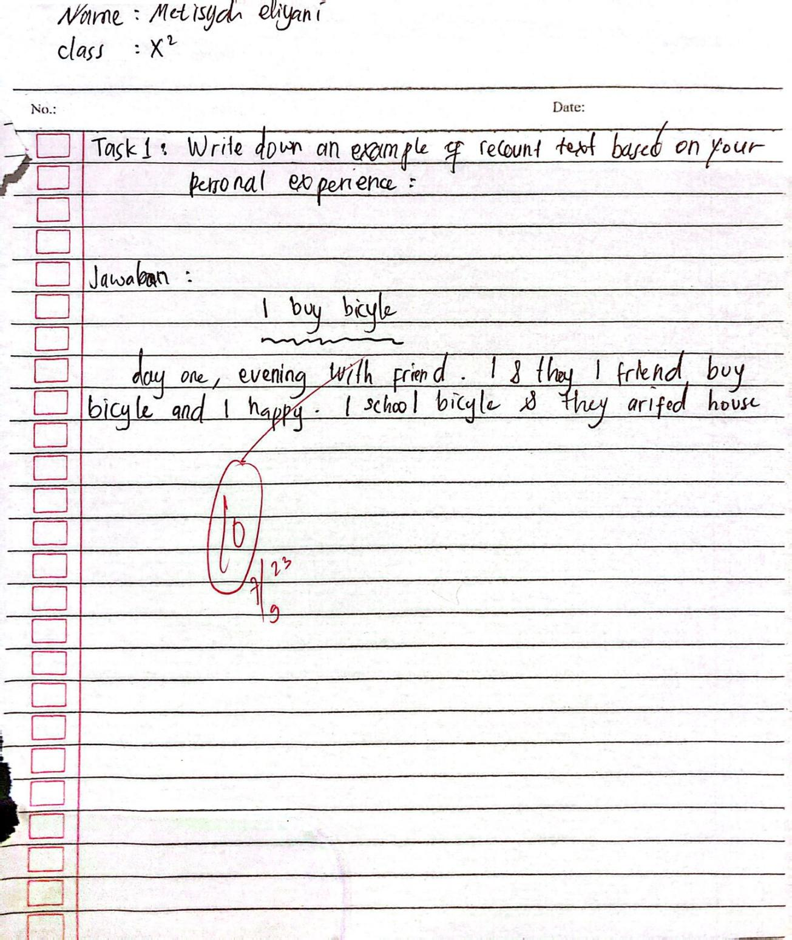

Participant 6

